Exploring Quadratics Using A Football
**This exercise is to be done after a lesson/review on the quadratic equation/parabolas. It will show students how to determine the equation of a kick/throw of a football by solving for unknowns. It will help them better understand the three different forms of a quadratic equation the vertex, and x intercepts while relating the math to a real life scenario. Optional skill testing questions can be added onto the end, as well as expanding the content area into physics to include velocities depending on the capability level the students are currently at.
1. The first thing we need to do for the exercise is to have a video camera ready and something to center in the frame so that a scale can be made. A brick wall is what we will be using in this explanation, but you can use whatever you can (such as a flagpole, etc.). It is important that you know the height of what you choose to center in the frame, and that the height is not shorter than a height the students will be able to throw the football to.
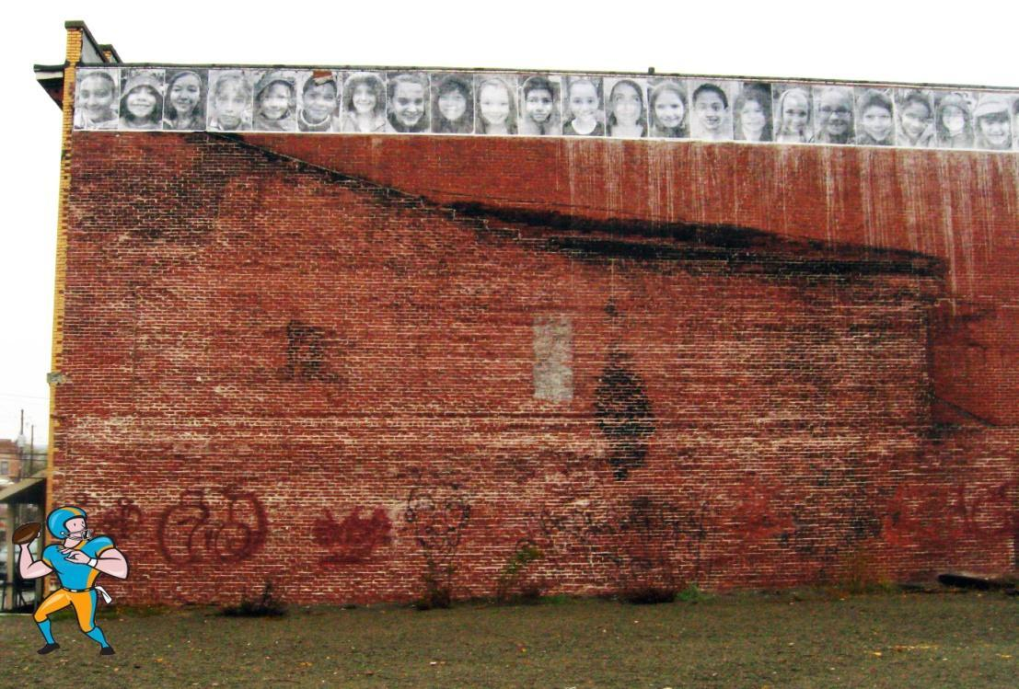
2. Have the student throwing the football stand at the left side of the frame like such.

Now each student can throw the ball or kick the ball while being videotaped. If you choose to do extension questions at the end you can tell the students what the scenario is when they throw. A couple examples would be: they are trying to kick a field goal and the posts are are (x,y) coordinates where x/y are in meters/feet, they are trying to throw to a teammate running at a certain speed, throwing to a fellow student who is running, etc.

3. Once everyone has had a chance to throw or kick, you can take the students back inside to where measurements will be taken. The easiest way to do this would be with the use of a smartboard, as you would be able to draw the everything right on top of the video, but a regular computer screen will work too. You will be measuring the height and length of the wall/scale item in the frame with a ruler/meter stick. Since you already know the height of the object in the frame, you can divide the height of the wall/object by your measurement on the screen to get a ratio of actual height of the football to height seen on the screen. Same goes for the length. An alternative for the length portion would be to use something to measure the throw as the student are throwing it (such as a meter wheel), which would be perfectly fine. If you are extending the exercise to include physics problems, you can also time how long the football is in the air so that velocities can be calculated.
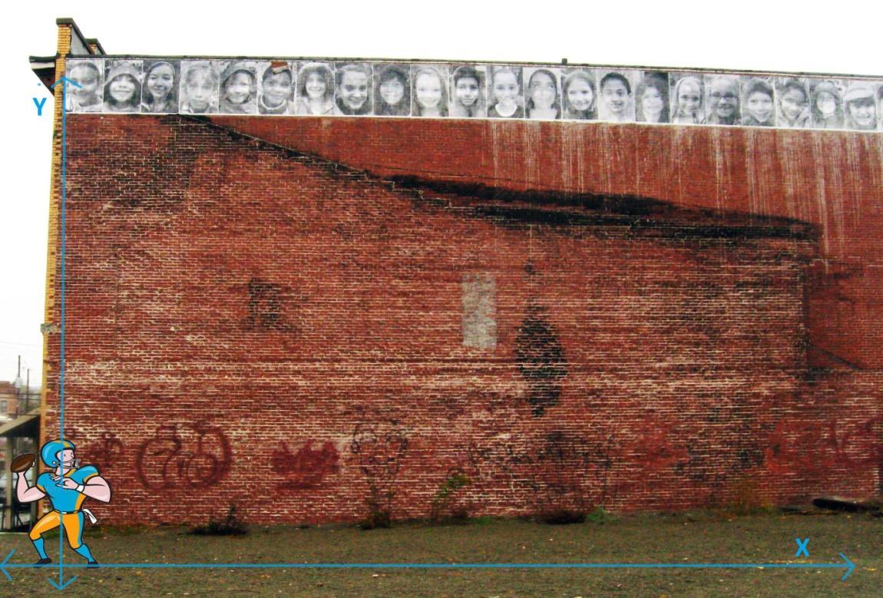
4. Once the ratio is calculated, the quadratic plotting can begin. The axis can be set up as such:

Where the Y axis is the height of the football and the X axis is the distance. Using the video, you can determine the vertex of the throw/kick by finding the maximum height using the video. You will pause the video when the football is at max height, and measure the height on the screen. To determine the actual height, you will take this height and multiply by the ratio determined in the previous step. Doing the same for distance (unless you manually measured it while outside) will find you the coordinates of the vertex: (h,k)=(max height, distance it occurs). You can do the same for when the football hits the ground. This will be the one of the x intercepts/zeros. You can also get the Y intercept if they threw the ball by measuring the starting height of the football.

5. Now that they have the vertex and an x intercept, you can send them off to do the math portion. First, we'll talk about if they kicked the ball. Since the ball starts on the ground in this scenario, the second x intercept will just be (0,0), but don't tell the students this. Let them try to determine the equation of their parabola on their own. The second scenario regarding a throw will have a second x intercept in the negative portion of the x axis, since the ball is starting at the height of their hand.
You should instruct the students to determine the equation of the parabola using one of two methods. The methods they can use are: A)Vertex Form Method & B) Factored Form Method. If they kicked the ball, it could also be useful to make them use both methods to show they lead to the same answer.
A) In vertex form method, they will start with the vertex form of the parabola equation as such:
y=a(x-h)²+k, using the vertex they found, they will fill in h and k in the equation. So say the max height was 20 meters and they threw it 20 meters, the vertex would be (20,20) and they would fill in
y=a(x-20)²+20. Now, to find a, they will have to plug in another point they know, which would be one of the x intercepts. So, if they threw the ball 40 meters, the x intercept would be (40,0) so they would get 0=a(40-20)²+20. rearranging and solving for gives an answer of -20/400. The answer for a is negative because the parabola opens down. They can now expand the equation to get the standard form.
B) In factored form method, you use the form y=(x-x₁)(x-x₂), where x₁ and x₂ are the x intercepts. From there you can just expand to get the quadratic polynomial using FOIL (first, outside, inside last).
Once this is done, they can plot the parabola that represents their throw (and submit it if you choose). If the student threw the ball, be sure to ask them to determine the second root, which will be in the negative x axis.
Be sure to ask the students knowledge testing questions. Why is the value of ‘a’ negative? Why do we only know one x intercept when you throw the ball? Questions like these add an inquiry element to the lesson.
This activity can also be adapted to be set up into groups, where students will throw at different angles so the group can map out different types of parabolas and see the differences in their equations
Extensions) If you chose to do an extension problem, such as the field goal posts, you can have them draw in where the posts would be on the plot. The use of smartboard would be very beneficial here as you can draw in the posts on screen and watch real time with the video to see if they made it. It would be a very fun activity for the students. The physics problems are also a good idea if you want to challenge the students. This depends on their knowledge of velocities.

