Genetians on Planet Mendel

You are a scientist studying who has just discovered a race on a different planet, Mendel. Genetians are tentacled-organisms that look similar to Earth’s species of octopus. It is your job to determine the traits of these creatures, the genotypes based on the pictures you have taken in your field research.
By communicating with a local Genetian named Tentaclina, you have discovered what the dominant traits are in their race. You know that having six (6) tentacles is a dominant trait, and any number less than that is a recessive trait. Many of the Genetians have antennae on their heads, although some of them do not have any. Large antennae are considered a dominant trait and no antennae is the recessive trait. However, you notice that Tentaclina has small antennae, and she explains only one of her parents had antennae. From this you realize that small antennae are a heterozygous trait. The last phenotype you notice is that many of the Genetians have spots of green colour, yellow colour, or both colours. An alien with only green spots possesses the dominant allele over aliens with only yellow spots, which possesses the recessive allele.
Based on this information, work in pairs to complete the questions on the worksheet below.

Create genotypic shorthand that you will use in creating Punnett Squares.
The letter ____T/t____ will represent the number of tentacles on an alien.
The letter ____A/a_______ will represent the size of the antennae on an alien.
The letter ___G________ will represent the colour of green spots on an alien.
The letter _____Y______ will represent the colour of yellow spots on an alien.

Phenotype | Six Tentacles | Six Tentacles | Four Tentacles
Genotype | TT | Tt | tt
 | Homozygous Dominant | Heterozygous | Homozygous Recessive

The number of tentacles is an example of ___Complete______________ dominance.

Phenotype | Large Antennae | Small Antennae | No Antennae
Genotype | AA | Aa | aa
 | Homozygous Dominant | Heterozygous | Homozygous Recessive

The size/presence of antennae is an example of ___Incomplete______________ dominance.

Phenotype | Green Spots | Green & Yellow Spots | Yellow Spots
Genotype | GG | GY | YY
 | Homozygous Dominant | Heterozygous | Homozygous Dominant

The spot colour is an example of __Co-dominance_________________________.

Determine the phenotype and genotype for the following aliens:

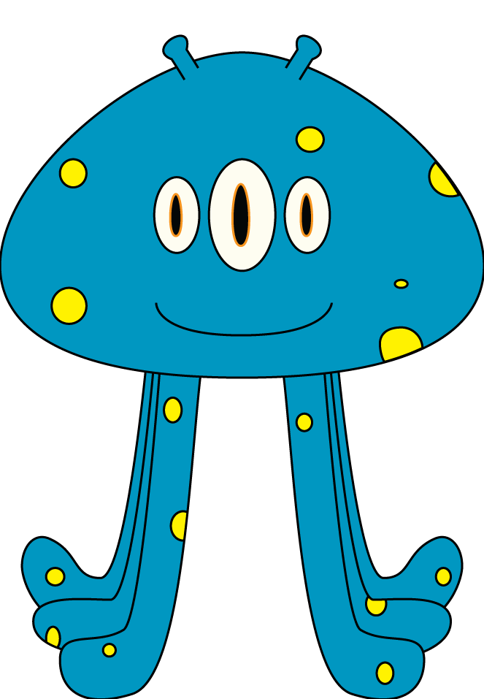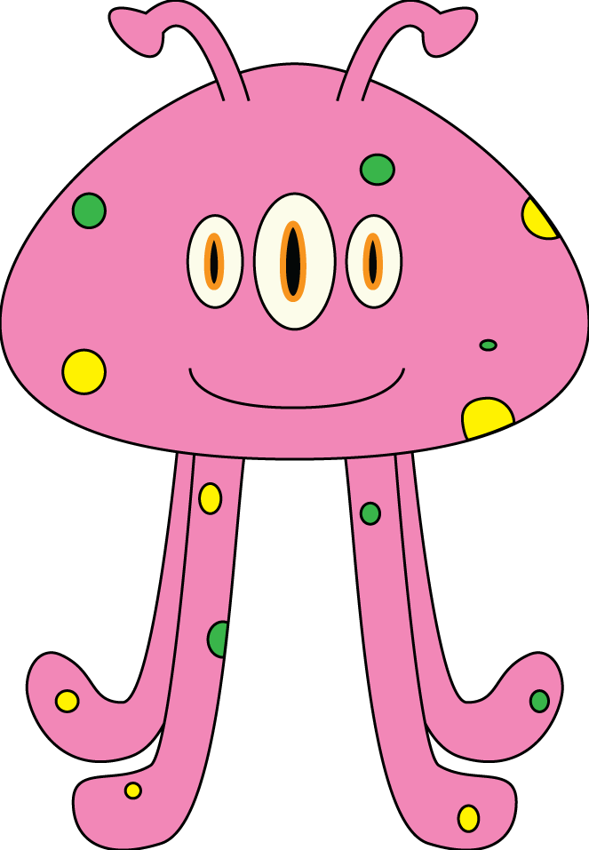

Subject 1 Subject 2

Phenotype |  | Genotype | Phenotype |  | Genotype
# of Tentacles | 6 | TT ot Tt | # of Tentacles | 4 | tt
Antennae | Small | Aa | Antennae | Large | AA
Spot Colour | Yellow | YY | Spot Colour | Green and Yellow | GY

The two subjects are thinking of having a child. Construct a Punnett Square for each trait (3 separate Punnett squares) to predict the probability of what the child could inherit.

t
T
T
T
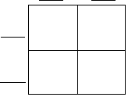
Tt
tt
Tt
t
Tt
t

tt
Tt
Tt
t
Tt

a
A

A
Antennae
Aa
AA

Aa
AA
A

Y
Y
G
GY
GY

Spot Colour

YY
YY
Y

You are given a bag of cutouts of Tentaclina and her friends. From the bag, you must determine which of the aliens is Tentaclina and her friend Antennio.
In this example:

Appearance of Traits in Genetians
Trait (shorthand) | Homozygous for Dominant Allele | Heterozygous | Homozygous for Recessive Allele
# of Tentacles (T/t) | Six Tentacles | Six Tentacles | Four Tentacles
Antenna (A/a) | Large Antenna | Small Antenna | No Antenna
Spot Colour (G/Y) | Green Only | Yellow and Green | Yellow Only

Anntenio’s Genotype: TtGYAA
Tentaclina’s Genotype: TTGGAa

Write down the cutout number you’ve chosen for Tentaclina and Antennio. Once you’ve found Tentaclina and Antennio, determine the genotypes for the other Genetians in the bag.

1) __________________

2) __________________

3) __________________

4) __________________

5) __________________

6) __________________

7) __________________

8) __________________

Cutouts:

