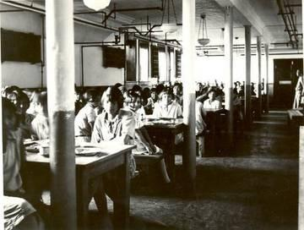

Children's dining room, Indian Residential School,
Edmonton, Alberta. Between 1925-1936. United Church
Archives, Toronto, From Mission to Partnership Collection.

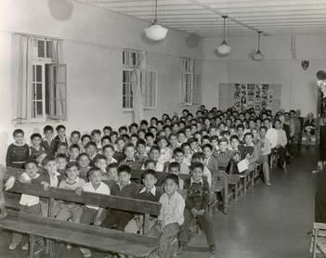

Male students in the assembly hall of the Alberni Indian
Residential School, 1960s. United Church Archives,
Toronto, from Mission to Partnership Collection

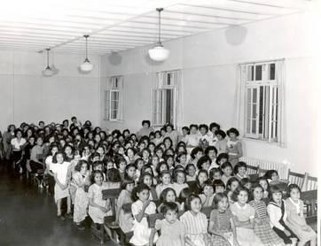

Female students in the assembly hall of the Alberni
Indian Residential School, 1960s. United Church
Archives, Toronto, from Mission to Partnership
Collection.
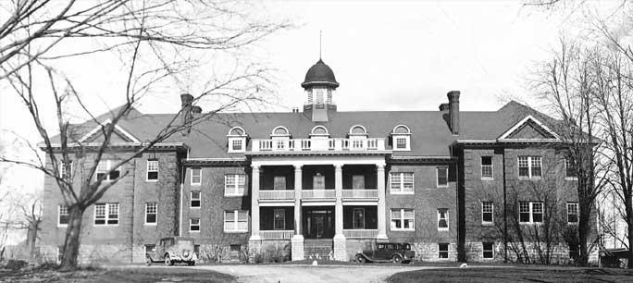

Mohawk Indian Residential School in Brantford, ON. Opened in 1831

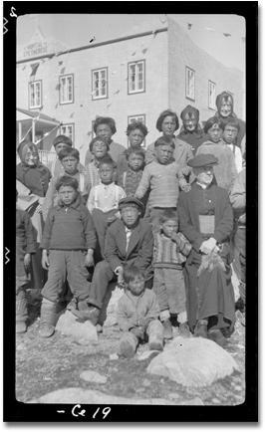

Inuit children in a residential school

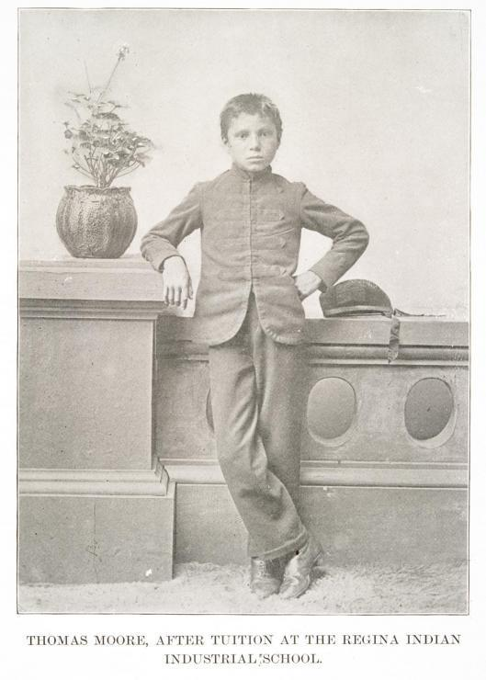

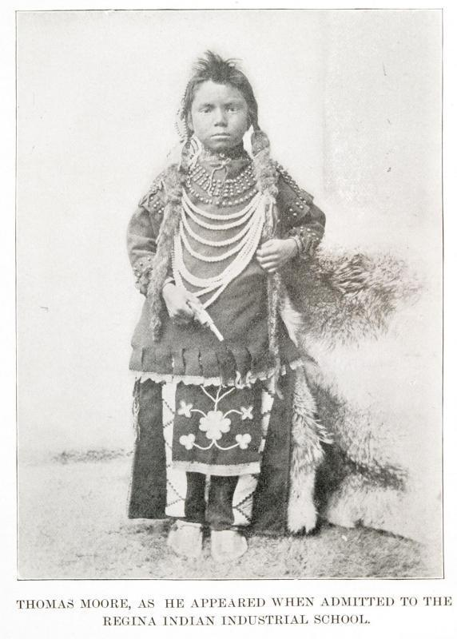
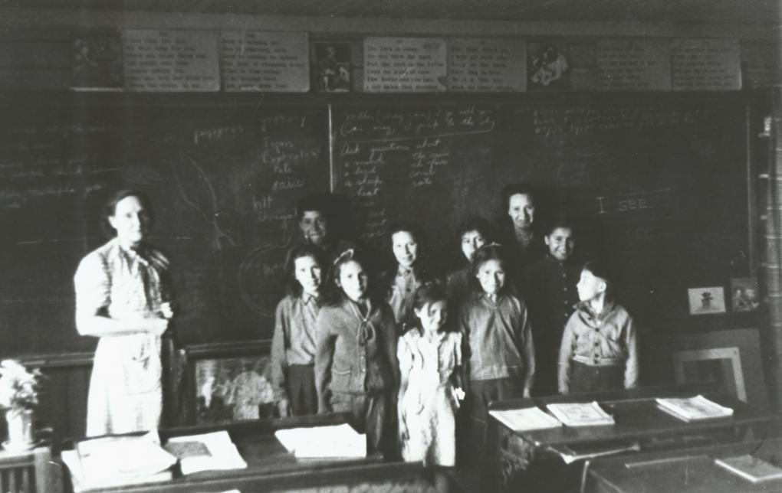

Jennie Wright and her class of Métis students, 1950. Photo: Canadian
Museum of Civilization, image 2002-2

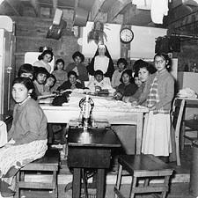

Aboriginal girls in sewing class, 1960 Photographer: Sister Liliane Library and Archives Canada, PA-195125

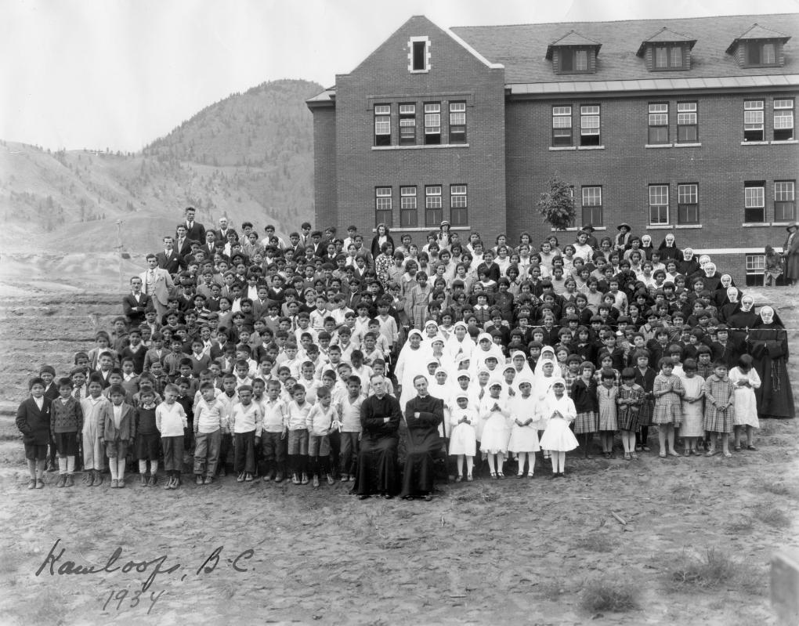
Aboriginal students and staff assembled outside the Kamloops Indian Residential School, Kamloops, British Columbia, 1934 Archives Deschâtelets

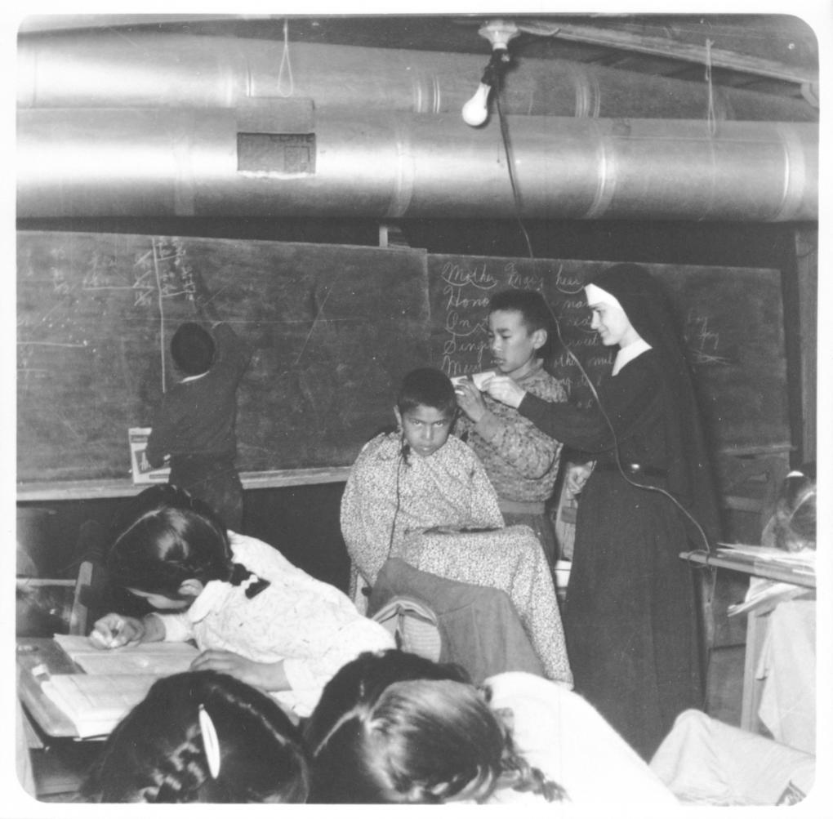
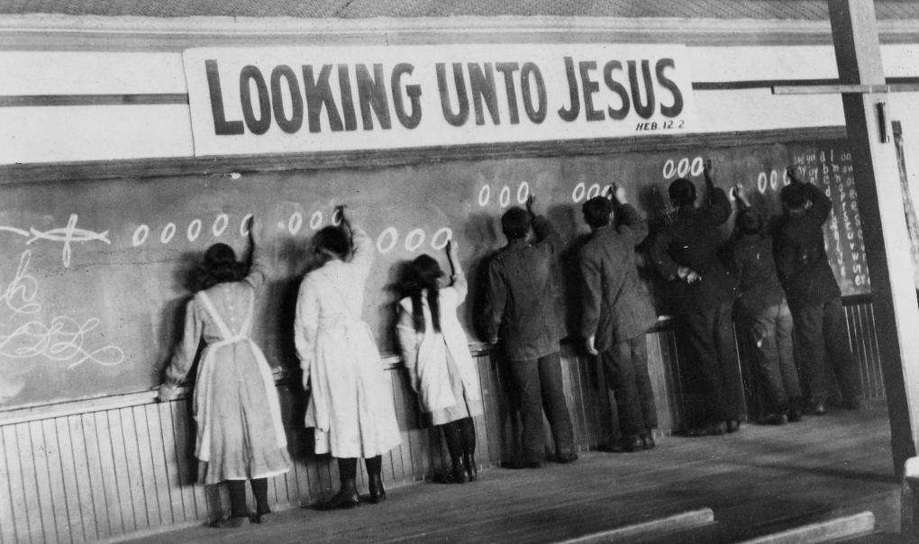
An Aboriginal boy having his hair cut, 1960 Photographer: Sister Liliane Library and Archives Canada, PA-195124

“Looking Unto Jesus.” A class in penmanship at the Red Deer Indian Industrial School, Red Deer, Alberta, ca. 1914 or 1919. United Church of Canada, Archives,93.049P/850N

