Lesson: Right Angle Triangles and the Pythagorean Theorem

Course: Grade 9 Academic Math (MPM 1D)

Specific Expectations from the Ontario Curriculum Document
- identify geometric properties of triangles
– relate the geometric representation of the Pythagorean Theorem and the algebraic representation a² + b² = c²

Learning Goals
By the end of this lesson students should be able to:
- Identify the properties of the different types of triangles and distinguish between them
- Identify what makes a right angle triangle
- Understand the concept of the Pythagorean Theorem
- Be able to apply the formula for the Pythagorean Theorem to right angle triangles

Minds On
-Put students into groups of six and assign each student in the group a type of triangle (scalene, isosceles, equilateral, acute, right, and obtuse)
-The students will be doing a RAFT (role, audience, form, and topic). Each student will learn about their type of triangle and then present to their group in the role of the triangle (i.e. I have three equal sides, none of my sides are equal, etc.)
-In this way students will become familiar with all types of triangles

Action
- Give students the worksheet titled “Right Angle Triangles and the Pythagorean Theorem”(pages 2-3, answers page 4-5)
- Put on the video and have students fill in the blanks on their worksheet along with the video
- Make sure to pause when the video says and have the students complete the activity described in the video. Go around and make sure the students understand the instructions.
- Go through the Pythagorean Theorem examples shown in the video.

Consolidation
-Put the following questions on the board:
- Describe the features of a right angle triangle.
- What is the hypotenuse?
- Why is the Pythagorean Theorem useful
-Have the students discuss the three questions with their elbow partner.
-Give the students the handout entitled “Finding the Unknown Side of a Right Triangle” (see page 6) and let them work on it till the end of class.

Right Angle Triangles and the Pythagorean Theorem
Date:_________________________
Name:_________________________

Introduction
A right angle triangle is one that has a _____________________ which is an angle that is ______.

Hypotenuse
The hypotenuse is the _______________ side of a right triangle. It is also the side that is _________________ from the right angle.

Activity
Measure the lengths of each side of the triangle below. Then find the area of the attached square for all three sides.

Draw your own right triangle Try it with your own right angle triangle now.

What did you notice from the activity?

Pythagorean Theorem
To find the length of the hypotenuse, we can use the Pythagorean Theorem.
a
b
c

______ represents the hypotenuse. ______ and ______ represent the other sides.

The Pythagorean Theorem is: c² = a² + b²

Example 1: Find the length of the hypotenuse.
5

3

Example 2: Find the length of the unknown side.
7
12

Right Angle Triangles and the Pythagorean Theorem-Answers
Date:_________________________
Name:_________________________

Introduction
A right angle triangle is one that has a right angle which is an angle that is 90º.

Hypotenuse
The hypotenuse is the longest side of a right triangle. It is also the side that is opposite from the right angle.
Hypotenuse

Right Angle

Activity
Measure the lengths of each side of the triangle below. Then find the area of the attached square for all three sides.

Draw your own right triangle Try it with your own right angle triangle now.

What did you notice from the activity?
The area of the square with the hypotenuse side length equals the sum of the other two areas.
Pythagorean Theorem
To find the length of the hypotenuse, we can use the Pythagorean Theorem.
a
b
c

c represents the hypotenuse. a and b represent the other sides.

The Pythagorean Theorem is: c² = a² + b²

Example 1: Find the length of the hypotenuse.
c² = a² + b²
= 3² + 5²
= 9 + 25
= 34 units
5

3

Example 2: Find the length of the unknown side.
c² = a² + b²
12² = 7² + b²
144 = 49 + b²
95 = b²
(95)^{1/2} = b
b = 9.75 units

7
12

Finding the Unknown Side of a Right Triangle
Name:_________________________
Date:_________________________

Find the length of the missing side of the right triangle below:

1.  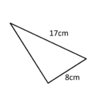 | 2.  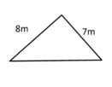 | 3.  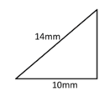
4.  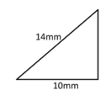 | 5.  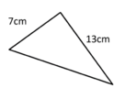 | 6.  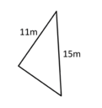
7.  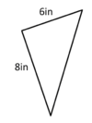 | 8.  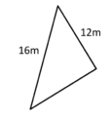 | 9.  