Lesson Plan- Societal Needs for Scientific and Technological Developments

Teacher: | Amanda Hanley, Jordan Dupuis, Courtney Bear, Mackenzie Tourigny-Conroy
Course: | SBI3U
Date:
Duration: | 75min
Strand: | Animals: Structure and Function
Topic: | Digestive System
Overall expectations: | E.2 Investigate through laboratory inquiry or computer stimulation, the functional responses of the respiratory and circulatory systems of animals, and the relationship between their respiratory, circulatory, and digestive systems  E3. Demonstrate an understanding of animal anatomy and physiology and describe disorders of the respiratory, circulatory and digestive system
Specific expectations: | E2.1 Use appropriate terminology related to animal anatomy, including, but not limited to: systolic, diastolic, diffusion gradient, inhalation, exhalation, coronary, cardiac, ulcer, asthma, and constipation
 | E2.2 Explain the anatomy of the digestive system and the importance of digestion in providing nutrients needed for energy and growth (eg. The body’s mechanical and chemical processes digest food, which provides the proteins needed to build muscle, and the fibre, water, vitamins and minerals needed to regulate body processes)

Learning Goals: | By the end of the lesson, students will be able to:  - Identify the different organs in the digestive system including the accessory organs  - Describe the functions of each organ in the digestive system  - Explain how the bolus moves through the alimentary canal via specific muscular contractions (peristalsis)

Resources and materials:
- Projector
- Computer with access to PowerPoint and Internet
- Small bucket, nylons, tennis ball, water and dish soap (X5)

Prior Knowledge:
- Basic understanding of the function and main components of the digestive system

Introductory Activity:

Introduction to the Digestive system video (muti-literacy video)
A brief overview of the structure and function of the main components of the digestive tract

Lesson:
- Note/Handout (attached)
- Labelling the digestive tract
- The components of the digestive system and their function
- Types of digestion

- Activity: Mimic Peristalsis
- Students are given the following:
  - a bucket
  - a piece of nylon, cut at both ends so there are openings on either side
  - A tennis ball
  - Water and dish soap
- Students must use these materials to demonstrate peristalsis.
- The nylon acts as the esophagus, the tennis ball acts as the bolus. The water and dish soap act as saliva and mucus respectively. The bucket acts as the stomach. The student’s hands act as the peristaltic muscular movements.
- Students will mimic the bolus travelling through the esophagus using the materials and show the teacher when completed, explaining which each part (nylon, tennis ball, etc.) represent in the digestive tract.

Differentiated Instructional Strategies / Considerations:
- Material presented for various learning styles. Videos and pictures for visual learners, Note/lesson for audio learners and activity mimicking peristalsis for the kinesthetic learners

Ongoing Assessment / Evaluation:
- Students show an understanding of peristalsis through the activity
- Questions on unit test

Resources for this lesson:

The Ontario Curriculum Grades 11 and 12, Science. 2008. Ministry of Education

Annab A, O’Connell, Winkelman M. 2012. Biology 11: College Preparation, Student Edition

The Digestive System
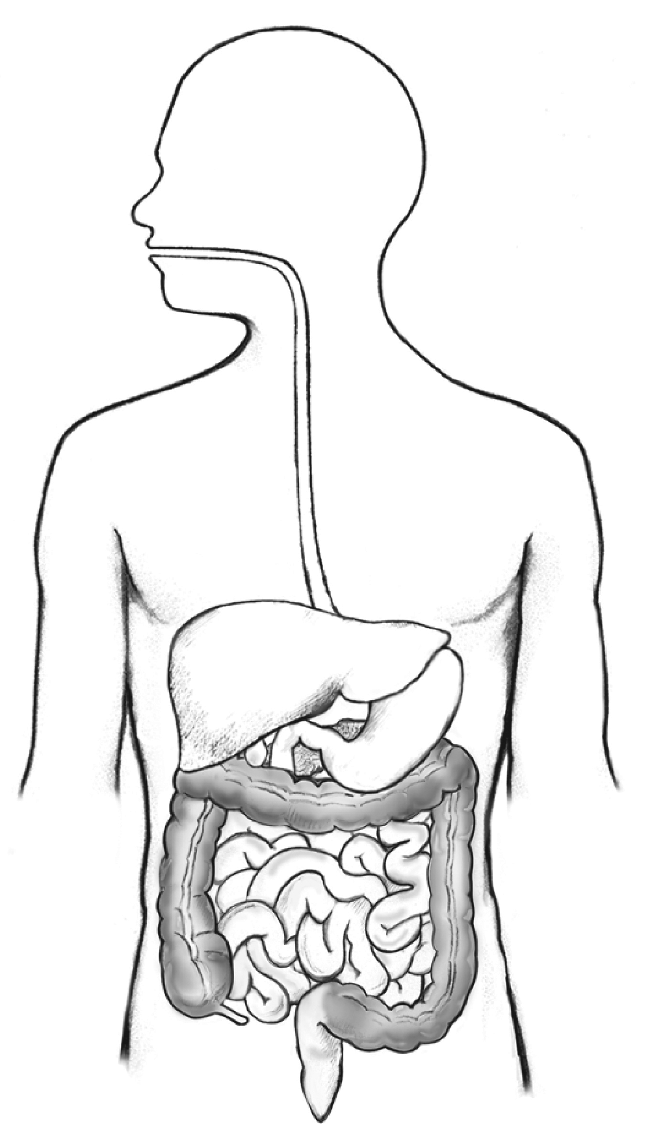

The Parts of the Digestive System

Part | Function | Type of Digestion
Mouth
 | Pushes food to your stomach through wave-like muscle movements
 | The muscle the squeezes to mix food and releases chemicals to break up food.
Small Intestine
Small Intestine
 | Removes waste from the body.

Types of Digestion

- Your digestive system breaks down food you eat to get the nutrients your body needs.
- This occurs in 3 processes:
Type of Digestion | What Happens | Where
Mechanical Digestion
 | Chemicals break down food into even smaller pieces. These chemicals are called enzymes.
Absorption

