Station #1

Instructions: Having gained foundational knowledge on the concept of sexism, the class will participate in identifying and reflecting on the issue. This station will focus on sexism, specifically in modes of advertising, such as: television commercials and advertisements found in magazines and newspapers. The students will watch Jean Kilbourne’s Killing Us Softly, which talks about the objectification of women in different modes of media. From this, students should be able to see the difference between the depictions of men and women in advertising and the sexism that exists in media.

Step 1: Watch 4:57 trailer of Jean Kilbourne’s Killing Us Softly.
Step 2: Allow students time (approximately 3-5 minutes) to answer the following questions with their elbow partner(s) and return to a large group discussion/reflection on the questions.

VIDEO: http://www.bing.com/videos/search?q=killing+us+softly+documentary&view=detail&&&mid=61ADA47B2FC6B862C02B61ADA47B2FC6B862C02B&rvsmid=61ADA47B2FC6B862C02B61ADA47B2FC6B862C02B#view=detail&mid=61ADA47B2FC6B862C02B61ADA47B2FC6B862C02B

Reflection Questions

- In the opening of the trailer, Jean Kilbourne states that she believes sexism in media and advertising has only gotten worse over the last 40 years. Do you agree or disagree? Justify your answer.
- In each of the advertisements shown, what is being done to women?
- In the trailer, Kilbourne connects the objectification of women to violence against women. What connection do you think exists between the two?
- Do you believe men experience the same treatment in advertisements that women do? There is no wrong answer, just be sure to justify and support your claims.

Once Station #1 is complete, please move on to Station #2.

Station #2
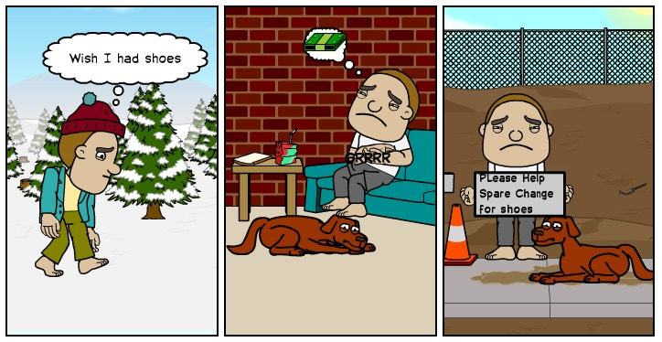
Reflection Questions
1. What do you notice about the above scene?
2. What emotions or expressions are portrayed?
3.What social issue is this portrayed? What examples lead you to this conclusion?

Station #3

Instructions: Students will listen to and receive a hard copy of the lyrics to Tupac Shakur’s 1998 hit Changes. After listening to the entire song, students will have the opportunity to use their hard copies as references for their discussion.

Step 1: Distribute hardcopies and have students listen to Tupac’s Changes.
Step 2: After listening to the song, give students the opportunity to look at the lyrics individually for approximately 2 minutes. Following this independent reflection, come together as a group and answer the following reflection questions.

Song
http://www.bing.com/videos/search?q=tupac+changes+lyrics&view=detail&&&mid=0C9BADEDF72D11E7C0A10C9BADEDF72D11E7C0A1&rvsmid=0C9BADEDF72D11E7C0A10C9BADEDF72D11E7C0A1#view=detail&mid=0C9BADEDF72D11E7C0A10C9BADEDF72D11E7C0A1

Lyrics

Come on come on
I see no changes wake up in the morning and I ask myself
Is life worth living should I blast myself?
I'm tired of bein' poor and even worse I'm black
My stomach hurts so I'm lookin' for a purse to snatch
Cops give a damn about a negro
Pull the trigger kill a nigga he's a hero
Give the crack to the kids who the hell cares
One less hungry mouth on the welfare
First ship 'em dope and let 'em deal the brothers
Give 'em guns step back watch 'em kill each other
It's time to fight back that's what Huey said
Two shots in the dark now Huey's dead
I got love for my brother but we can never go nowhere
Unless we share with each other
We gotta start makin' changes
Learn to see me as a brother instead of two distant strangers
And that's how it's supposed to be
How can the Devil take a brother if he's close to me?
I'd love to go back to when we played as kids
But things changed, and that's the way it is
[Chorus: x2]
That's just the way it is
Things will never be the same
That's just the way it is
Aww yeah
I see no changes all I see is racist faces
Misplaced hate makes disgrace to races
We under I wonder what it takes to make this
One better place, let's erase the wasted
Take the evil out the people they'll be acting right
'Cause both black and white is smokin' crack tonight
And only time we chill is when we kill each other
It takes skill to be real, time to heal each other
And although it seems heaven sent
We ain't ready, to see a black President, uhh
It ain't a secret don't conceal the fact
The penitentiary's packed, and it's filled with blacks
But some things will never change
Try to show another way but you stayin' in the dope game
Now tell me what's a mother to do
Bein' real don't appeal to the brother in you
You gotta operate the easy way
"I made a G today" But you made it in a sleazy way
Sellin' crack to the kid. " I gotta get paid,"
Well hey, well that's the way it is
[Chorus: x2]
We gotta make a change
It's time for us as a people to start makin' some changes.
Let's change the way we eat, let's change the way we live
And let's change the way we treat each other.
You see the old way wasn't working so it's on us to do
What we gotta do, to survive.
And still I see no changes can't a brother get a little peace
It's war on the streets and the war in the Middle East
Instead of war on poverty they got a war on drugs
So the police can bother me
And I ain't never did a crime I ain't have to do
But now I'm back with the blacks givin' it back to you
Don't let 'em jack you up, back you up,
Crack you up and pimp smack you up
You gotta learn to hold ya own
They get jealous when they see ya with ya mobile phone
But tell the cops they can't touch this
I don't trust this when they try to rush I bust this
That's the sound of my tool you say it ain't cool
My mama didn't raise no fool
And as long as I stay black I gotta stay strapped
And I never get to lay back
'Cause I always got to worry 'bout the pay backs
Some buck that I roughed up way back
Comin' back after all these years
Rat-a-tat-tat-tat-tat that's the way it is uhh
[Chorus: x2]
Some things will never change

Reflection Questions

1. Upon listening to the song, what perspective do you believe the lyrics are being sung from?

2. In the song, Tupac says: “I'd love to go back to when we played as kids
But things changed, and that's the way it is.” What do you think this line means? Do you believe racism is inherent or taught?

3. Given the events that have been widely documented between police officers and young black people in the United States, which part of this song highlights this issue and do you personally believe relations between police officers and black people have improved at all over the last 17 years when this song was first made? Justify your answer.

4. Looking at the lyrics of the song, which verse stands out most to you? Why did you choose this verse?

Station #4 - Penny Activity

Pennies represent wealth and power
1. Distribute gloves, mittens and blindfolds to group members (except 2)
2. Scatter pennies in the middle of the desk
3. One of the group members without glove/mittens/blindfold count down 1-2-3-go
4. Group members are to try and collect as many pennies as possible without touching each other.
5. Have group members report their “wealth” to the rest of the group
a. Less than 3 pennies = Little wealth and power
b. 4-6 pennies = Some wealth and power
c. More than 6 = Great wealth and power
6. The amount of pennies you possess will affect the ability to satisfy your needs (basic food, shelter, clothing) and wants (extras such as computer, cars, television etc.).

DISCUSSION QUESTIONS

How did this activity make you feel?
Do you feel like it was fair?
How did it feel having gloves/mittens?
How did you feel if you didn’t have gloves/mittens?
What do you think this could possibly represent in society?

Station #5

Instructions: Students will look at different pictures that will be shown to them and they will have to point out what makes the pictures a stereotype and why. (discussion based)

CEO

What do you notice about this picture?

What stereotypes do you think pertain to this picture of a CEO?

NURSE
What do you notice about this picture?

What stereotypes do you think pertain to this picture of a nurse?

DOCTOR
What do you notice about this picture?

What stereotypes do you think pertain to this picture of a doctor?

LGBT COMMUNITY
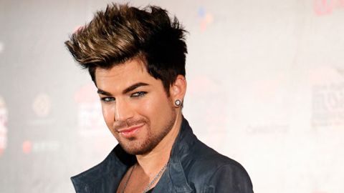
What do you notice about this picture?

What stereotypes do you think pertain to this individual?

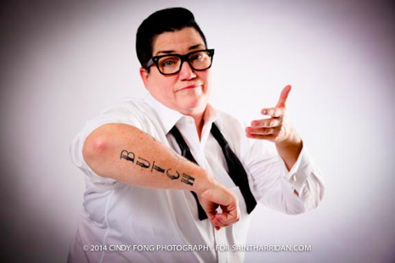
What do you notice about this picture?

What stereotypes do you think pertain to this individual?

CONVICTS
What do you notice about this picture?

What stereotypes do you think pertain to these individuals?

