Multiliteracies Project Lesson Plan – They’re Functions!
Date:____________________________________
Course: | MCR3U
Length: | 75 minutes
Topic: | “They’re Functions!” Multimodality Review Video of Basic Functions  - Introducing the concept of domain and range using multi-modality activity describing shapes of functions
Expectations:
Curriculum: | - A1.1, A1.3, B1.4, B2.1, D2.4
Learning Goals: | - “I can identify basic polynomial, exponential and trigonometric functions.”  - “I can identify characteristics of basic polynomial, exponential and trigonometric functions.”  - “I can determine domain and range of basic polynomial, exponential and trigonometric functions.”
Resources: | - Projector and computer, or Smartboard with internet access  - Chalkboard  - Paper and pencils  - Classroom space for movement  - Function Worksheet (Picture of body movement with graph superimposed. Students asked to determine domain and range of functions.)
Teaching Strategies:
Intro/Get Started: | - Introduce learning goals for the day (written on the Learning Goals board) (2 minutes)  Learning Goals:  - “I can identify basic polynomial, exponential and trigonometric functions.”  - “I can identify characteristics of basic polynomial, exponential and trigonometric functions.”  - “I can determine domain and range of basic polynomial, exponential and trigonometric functions.”  - Have students complete a KWL chart to review prior knowledge and prepare for the lesson (2 minutes)  - Re-iterate what a function is (the most basic characteristics) using group discussion (2 minutes)  - Reviewing basic graph shapes of polynomial, exponential, and trigonometric function (5 minutes)  - Teacher Prompt:  - “If you were to draw the graph of y = x², what would it look like? What do we call this? Sketch its graph shape, x-axis and y-axis on your paper and hold up for me to see.”  - “If you were to draw the graph of the sine function, what would it look like? Sketch the basic shape, x-axis and y-axis on your paper and hold up for me to see.”
Explore/Development: | - What is domain and range? Lesson (15 minutes)  - Cartesian plane on the board or Smartboard  - What x values does the graph have? This indicates the domain.  - What y-values does the graph have? This indicate the range.  - Ex) y = x²  - 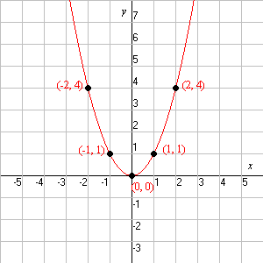  - Domain: {x ϵ R ; -∞ < x < ∞}  - Range: {y ϵ R ; 0 < y < ∞}, or {y ϵ R ; y > 0}  - Class Activity: Dance/Music Video and Interactive worksheet component (30-40 minutes)  - Pauses are for teacher explanations and student completion of domain and range of the respective function on the worksheet  - Encourage student movement to understand the graph as it goes to positive and negative infinite
Connect and Reflect/ Concluding Activity: | - Full class participation of the dance (8 minutes)  - Teacher prompts: (2 minutes)  - “What does the basic cubic look like? Show me with your arms.”  - “What is its domain?”  - “What is its range?”  - Follow-Up Activity:  - Encourage students to practice the dance at home  - Dance repeated at the beginning of next class
Method of Evaluation/ Assessment: | - Worksheet  - Participation  - Observation
Follow-up Ideas/Next Steps: | - Determining domain and range from equation of the graph  - Introduction of finding Inverse Functions using equations and graphs
Self-Reflection:

KWL Chart: Domain and Range of Functions
Know | Want to Know | Learned
They’re Functions! Lyrics
Polynomials, they’re functions, they’re functions, they’re functions!
Exponentials, they’re functions, they’re functions, they’re functions!
Trigonometric, they’re functions, they’re functions, they’re functions!
All of them, they’re functions, they’re functions, they’re funcions!!
Woo!
Polynomial functions come in many degrees
Such as 4, 6, 2, and 3
These are functions that never end
So we say they are continuous
End behaviour varies depending on degree
Let’s take a look together and see
Both sides of even go to infinity
For odd degree, ends go oppositely
[Pause]
Polynomials, they’re functions, they’re functions, they’re functions!
Exponentials, they’re functions, they’re functions, they’re functions!
Trigonometric, they’re functions, they’re functions, they’re functions!
All of them, they’re functions, they’re functions, they’re functions!!
Woo!
Exponentials they don’t have a degree
But they always go to infinity
They also have an asymptote
Which they cannot touch, but they get real close!
Next, let’s talk about the two forms
We have standard form and natural form
Standard is base “a” to the x
And natural is base “e” to the x
The asymptote may change
And affect the range
The domain will always stay the same
Now you know the rules of the game
Don’t let exponentials give you strife
Use them for depreciation and half-life
Now exponential functions come to a close
Get ready to pose
[Pause]
Hit it gang!
Polynomials, they’re functions, they’re functions, they’re functions!
Exponentials, they’re functions, they’re functions, they’re functions.!
Trigonometric, they’re functions, they’re functions, they’re functions!
All of them, they’re functions, they’re functions, they’re functions!!
Woo!
Trig functions they always repeat
Look at them they’re a specialty
There are three main types you need to know
Tangent, sine, and cosine, whoa
Cosine passes through the y
And sine goes through the origin, oh my
Tangent stands out from the others
It’s not continuous, oh brother
Sine and cosine share domain and range
Now you’ve gotta be thinking that sounds strange
Think back to behaviour of polynomial odd degree
That’s what tangent’s would be
Just remember the function repeats
Think about all of the beats
"Now what you hear may be on the test!"
So we hope this song helps you do your best!
[Pause]
Stand up, dance, and sing along!!

They’re Functions! Interactive Worksheet

Function Type | Visual Representation | Characteristics | Domain and Range
Polynomial | 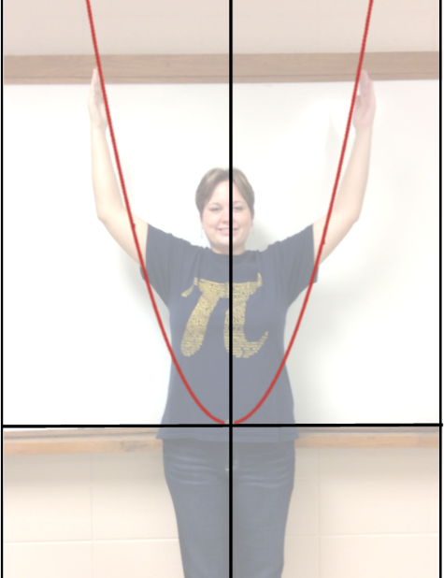
Polynomial | 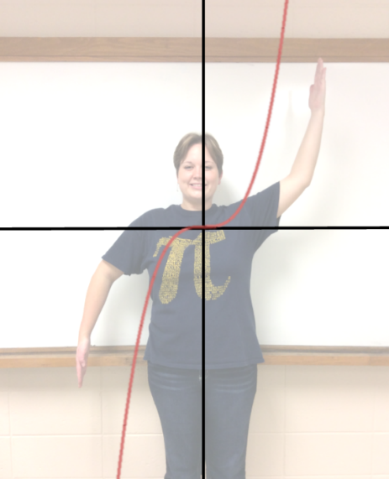
Exponential | 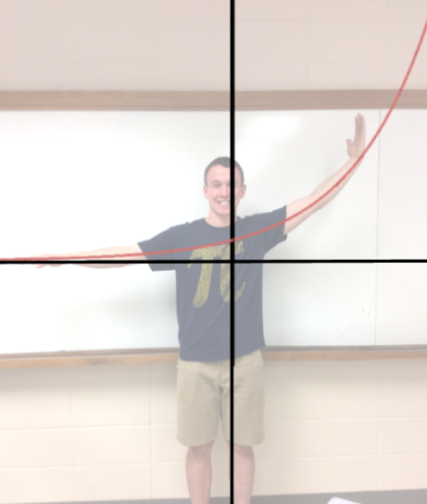
Trigonometric | 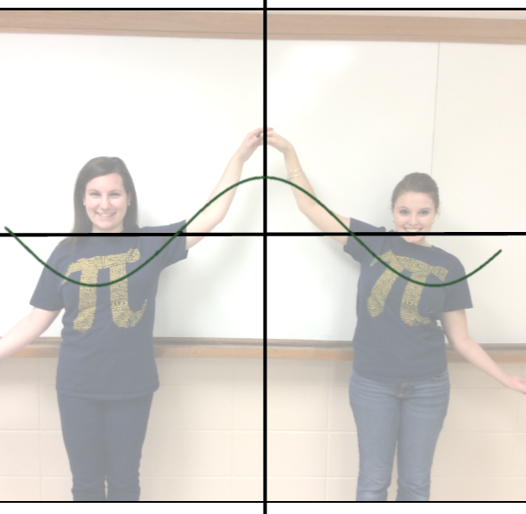
Trigonometric | 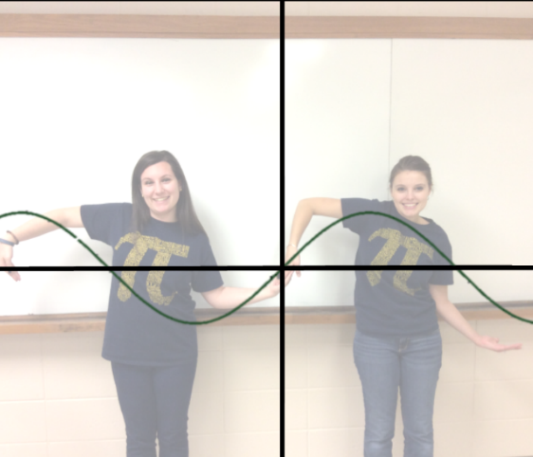
Trigonometric | 