Lesson Plans

Table of Contents
Whole Day Lesson Plan 3
Physical Literacy Lesson Plan 4
Power-Point Resource 6
GLO Database 9
Chuck The Chicken 9
Graffiti 11
Mathematics Game 13
What Time is it Mr. Wolf With Obstacles 14
Octopus 15
Handball With Soccer Component 17

Whole Day Lesson Plan

LESSON PLAN
Date:
Title of the Lesson: Physical Literacy & GLO
Unit of Study: GLO

Background Information:
Physical Literacy: the basic fundamental skills to complete tasks (Ex. Throwing, running, jumping, kicking). Intent is to ensure students are all physically literate.

GLO: Games of Low Organization, should not take up the entire class time, but are used to supplement the lesson.

Assessment:

Learning Expectations:
- Understanding the concept of physical literacy
- Knowing how the GLO chosen for the day applies to which physical literacy component
Lesson:  40 minutes  Physical Literacy Lesson  - Power-point presentation and discussion on what physical literacy is  35 minutes  GLO Activity  - Warm-up  - GLO activity chosen  - Cool down |  | Materials/Resources:  - Power-point presentation  - Materials needed for specific GLO
Bloom's Taxonomy:  Knowledge  Understanding  Application  Analysis  Synthesis  Evaluation | Multiple Intelligences:  Linguistic  Logical/Mathematical  Spatial  Musical  Bodily/Kinesthetic  Interpersonal  Intrapersonal  Naturalistic
Modifications
Exchange students:
- Modifications for GLOs based on physical literacy levels
- Power-point presentation is in resources, for the chance that powerpoint is not available to use

Physical Literacy Lesson Plan

LESSON PLAN
Date:
Title of the Lesson: Physical Literacy
Unit of Study: Physical Literacy

Background Information:
Physical Literacy: the basic fundamental skills to complete tasks (Ex. Throwing, running, jumping, kicking). Intent is to ensure students are all physically literate.
Assessment:
Class discussion based on the material presented by the educator. Ensuring that students understand the material that was presented to them
Learning Expectations:
- Know what physical literacy is
- Know how to improve, and know how to apply physical literacy
Lesson:  The New Standards for Physical Activity  - 24 hour movement guideline  - Sweat mod – vig = 60 mins/day  - Step light pa = several hours of both structured and unstructured  - Sleep = 9-11hrs/night 5-13; 8-10hrs/night 14-17  - Sit = no more than 2 hours/day  Physical Literacy  - the motivation, confidence, physical competence, knowledge and understanding that individuals develop in order to maintain physical activity at an appropriate level throughout their life  - Examples for physical literacy  - Running, jumping, throwing, kicking, etc.  Physical Literacy in Our Community  More About Physical Literay  Motivation and confidence domains include a child’s perceptions of his/her ability to be physically active (CAPL, 2014). Perceived motor competence is the greatest predictor of children’s physical activity (Babic, 2010), and is a proxy measure for motivation and confidence in physical literacy assessment. Little research has been done on children with visual impairments (VI) and their level of physical literacy, however, it is well documented that children with VI participate in significantly less physical activity than that of their sighted peers (Haegele & Poretta, 2014). Moreover, opportunities to foster self-determined motivation through physical activity are often not present for children with VI (Robinson & Lieberman, 2004). |  | Materials/Resources:  - Power-point presentation
Bloom's Taxonomy:  Knowledge  Understanding  Application  Analysis  Synthesis  Evaluation | Multiple Intelligences:  Linguistic  Logical/Mathematical  Spatial  Musical  Bodily/Kinesthetic  Interpersonal  Intrapersonal  Naturalistic
Modifications
Exchange students:
- If power-point is not available, skeleton notes of presentation in appendix

Power-Point Resource

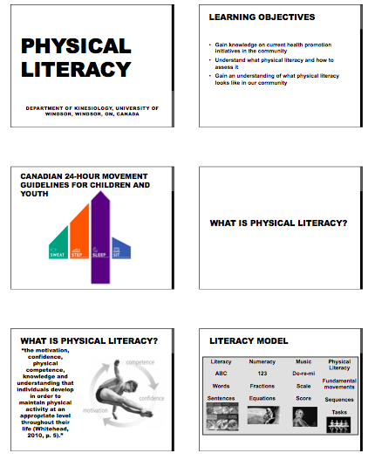
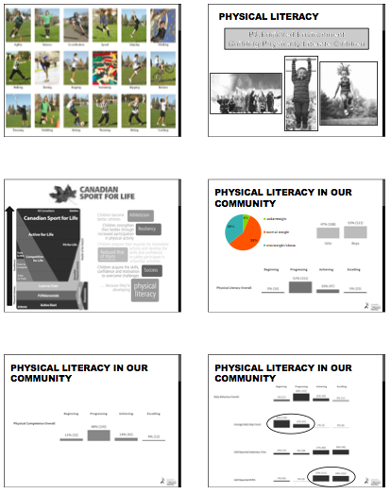

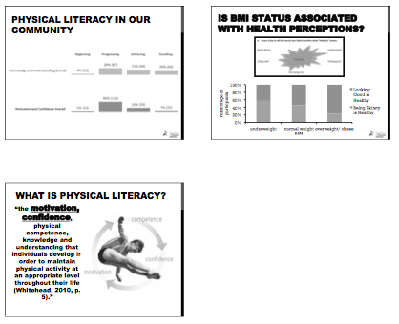

GLO Database

Chuck The Chicken

Activity: Chuck the Chicken Grade: 9-12 Unit: Physical Literacy GLO Date: ____________

Activities |  | Benefits of Health |  |  | Cooperation |  |  |  | Do it Daily… For Life
- Chuck the Chicken |  | - Increasing HR |  |  | - Teamwork & Cohesion |  |  |  | - Engagement
Basic skills | Application of Basic Skills | Functional Fitness | Body Image | Well-Being | Communication | Fair play | Leadership | Teamwork | Effort | Safety | Goal Setting/ Personal challenge | Active Living In the Community

Purpose:
- Chuck the Chicken is a fun interactive game where 2 teams work together strategically and cohesively to beat other team.
- Students will be required to run, throw, pass, and work together to complete task

GLO Guidelines:
- Split class into 2 teams
  - One team will begin as the throwers
  - Opposite team will chase where the chicken lands.
- Objective is to get points and in order to get the points you must have one team member run in a circle around all your group members as fast as you can.
  - 1 Full circle around your team members counts as 1 point
  - Can only begin running and gaining points after you chuck the chicken
- Objective of throwers: Immediately after throwing the chicken get teammates close together and have one teammate sprint around in a circle around team
- Other team sprints toward where chicken lands and teammates line up and pass chicken above head then through legs and so on in that pattern as quickly as possible. Once chicken gets passed to every teammate last person will chuck the chicken as far as they can away from the other team.
- Once this happens the team that was completing the circles and gathering points will stop and do the same as the other group. They will chase the chicken and make the line and go above and under. As soon as the group member throws the chicken its now time for the other team to score some points and get around group members as fast as possible.
- Team with the most points at the end of 3-5 mins wins

Modifications:
- Can change locomotion rules and apply speed walking or skipping

Equipment  - Rubber Chicken  - Open Concept Gym | Safety Considerations  - Do not throw chicken in direction of any students  - Be careful when running toward walls  - Be aware of your surroundings

https://www.youtube.com/watch?v=WQbK0nGe5xU

Graffiti

Activity: Graffiti Grade: 9-12 Unit: Physical Literacy GLO Date: ____________

Activities |  | Benefits of Health |  |  | Cooperation |  |  |  | Do it Daily… For Life
Basic skills | Application of Basic Skills | Functional Fitness | Body Image | Well-Being | Communication | Fair play | Leadership | Teamwork | Effort | Safety | Goal Setting/ Personal challenge | Active Living In the Community

Purpose/Explanation:
- Fun cross curricular activity used in the gym to activate and engage students mentally & physically
- Requires: running, working out, dynamic movements, thinking, writing, and teamwork

GLO Guidelines:
- There are 4 chart papers in each corner of the gym with specific words written on them
- Objective is to fill out as many words on that chart paper that you can possibly think of with your assigned marker. For example if the word is Friends you are to write as many words that come to mind when you think family like: Funny, trustworthy, social, fun, similarities etc. Each team will have a different coloured marker.
- You will only have 30-45 seconds at each station to think of words to write.
- However you are only allowed to begin writing your words after you complete the designated workout. For example one corner may be complete 10 pushups before writing so each group member must complete their pushups before you can begin writing. Another station will be to complete 10 Burpees.
- 4 teams will be split at each corner of the gym once the whistle blows to begin each group must complete the workout then begin writing
- Once you hear the whistle again it is time to run clockwise to the next chart paper and complete that designated workout for that chart paper and then begin writing new words for that new word.
- Continue this until each group has completed all 4 stations.
- The group with in most words in total on each paper wins that section.
- Students are not allowed to double up on words. If one group has already used a word you can not use the same word.

Modifications:
- If certain students are unable to perform certain workout modify or alter workout
- Choose suitable workouts based on group and personnel

Equipment  - Chart paper (4 pieces)  - Markers  - Whistle  - Stop watch | Safety Considerations  - Be careful when running to next station  - Complete workouts with proper for (Exemplify workouts before)
https://www.youtube.com/watch?v=CFDLAK9Omv8

Mathematics Game

Activity:Mathematics Game Grade: 9-12 Unit: Physical Literacy GLO Date: ____________

Activities |  | Benefits of Health |  |  | Cooperation |  |  |  | Do it Daily… For Life
Basic skills | Application of Basic Skills | Functional Fitness | Body Image | Well-Being | Communication | Fair play | Leadership | Teamwork | Effort | Safety | Goal Setting/ Personal challenge | Active Living In the Community

Purpose/Explanation:
- Cool interactive game that incorporates math and teamwork. Cross curricular activity that engages students mentally in a physical environment
- Requires: walking around, teamwork, communication, thinking, and leadership

GLO Activities/Guidelines:
- Students all pick cards with a random number on them. Some cards have the #2 some have #3 some with #4 and some with #5.
- All students hold out their cards in front of them and walk around the designated area in the gym randomly in all directions.
- The instructor then has his own cards with him and he chooses the number he wants to show and for example if the instructor holds out the # 8 the students are to work together and use each others numbers and group together to add their numbers to make 8
- Anyone who is left alone and did not form a group and failed to add the number 8 is out
- The goal is to work quickly with other students to form the number they instructor presents.

Modifications:
- Individuals with visual impairments can be paired or helped by another students and teacher can shout out the number as well.

Equipment  - Cards with Numbers for students  - Cards for presenting numbers | Safety Considerations  - Be careful when making groups no pushing or shoving
https://www.youtube.com/watch?v=Y63CWQOyh90

What Time is it Mr. Wolf With Obstacles

Activity: Mr. Wolf Obstacle Grade: 9-12 Unit: Physical Literacy GLO Date: ____________

Activities |  | Benefits of Health |  |  | Cooperation |  |  |  | Do it Daily… For Life
Basic skills | Application of Basic Skills | Functional Fitness | Body Image | Well-Being | Communication | Fair play | Leadership | Teamwork | Effort | Safety | Goal Setting/ Personal challenge | Active Living In the Community

Purpose/Explanation:
- Mr. Wolf Obstacle is an exciting challenging game that requires students to be attentive. Also requires balance, listening skills, strategy, quickness, and agility.

GLO Guidelines:
- Obstacle course is set up along the gym
- 1 student is the timekeeper (aka the wolf) and is situated at the end of the obstacle course facing away from students completing course.
- Students objective is to touch the wolfs shoulder in order to win. In order to reach the wolf you must complete the obstacle course leading toward the wolf.
- However, the wolf counts to 3 as fast or as slow as they want and once the reach the #3 they will quickly turn around… When the wolf says 3 you MUST freeze in what ever position you are in… if you move, fall, flinch, stumble and the wolf sees you, they will send you back to the beginning of the course and you must complete it again.
- Students are to complete course but also be aware that the wolf is trying to catch you so must freeze when they turn around and watch you.

Modifications:
- Change locomotion: walking only, skipping only, crawling only, etc.
- Students with movement disabilities may just skip obstacles and work on ambulating toward wolf and just freezing when 3 is shouted.

Equipment  - Mats  - Hula-hoops  - Benches  - Cones | Safety Considerations  - Must be aware that students may be balancing and walking on benches.  - Jumping or hurdling mats
https://www.youtube.com/watch?v=HwnMCIOdJwk

Octopus
Activity: Octopus Tag Grade: 9-12 Unit: Physical Literacy GLO Date: ________________

Activities |  | Benefits of Health |  |  | Cooperation |  |  |  | Do it Daily… For Life
Basic skills | Application of Basic Skills | Functional Fitness | Body Image | Well-Being | Communication | Fair play | Leadership | Teamwork | Effort | Safety | Goal Setting/ Personal challenge | Active Living In the Community

Purpose/ Explanation:
- Octopus Tag is high intensity and an entertaining game for all ages and challenges students to play one of the most famous games of all time… tag. With varying modifications
- Requires, running, walking, agility, strategy, and vision

GLO Guidelines:
- All of the students line up on one side of the playing area.
- One student is chosen to be octopus. (You can have someone volunteer or your choice)
- The octopus stands in the middle of the playing area.
- The octopus then yells “octopus” and everyone must run to the other side of the ocean (gym) where they are safe from being caught.
- If a student gets caught, they sit where they got caught and become seaweed.
  - Seaweed are allowed to help the octopus by remaining seated but their seaweed limbs can reach out and touch the “fish” as they run by.
  - If they catch a fish they too must sit and become seaweed.
- Once all the fish are caught the game is over and they may stand on one side of the ocean and the last fish that was left will get a chance to be the octopus for the next game.

Modifications:
  - To make it more difficult, or on larger playing fields (like a soccer field) you can have more than one octopus.
  - You can also change the means of locomotion, for example crab walk, skipping, speed walking etc.

Equipment  - None | Safety Considerations  - Keep head up when traveling to other side  - Instead of seaweed sitting maybe standing seaweed would be safer  - Students are to never hurdle seaweed if seated
https://www.youtube.com/watch?v=s5EdpydUKoc

Handball With Soccer Component
Activity: Soccer/Handball Grade: 9-12 Unit: Physical Literacy GLO Date: ____________

Activities |  | Benefits of Health |  |  | Cooperation |  |  |  | Do it Daily… For Life
Basic skills | Application of Basic Skills | Functional Fitness | Body Image | Well-Being | Communication | Fair play | Leadership | Teamwork | Effort | Safety | Goal Setting/ Personal challenge | Active Living In the Community

Purpose/Explanation:
- Soccer Handball is exactly what it sounds like. Soccer incorporated with handball. Its an exciting unusual creative game that involves both soccer and handball rules.
- Students are required to run, throw, catch, kick, defend, attack, and use different methods to reach end goal

GLO Guidelines:
- 2 equal teams are made and there will be 6 on the floor playing at a time on each team.
- The game will begin as handball and involve only the rules of handball. The purpose of handball is to pass between teammates and score on the other teams goal by throwing the ball into their net.
- However while passing the ball and playing against the other team, if the ball happens to drop or fall during the game the entire game switches and turns into soccer.
- Once the ball makes contact with the ground you are allowed to play soccer and pass and shoot the ball with your feet.
- The only way students can switch the game back to hand ball is by flicking the ball into their own hands using their feet or scooping the ball with their feet into someone’s hand.
- Once the ball is flicked back up and caught the game changes again to handball rules.
- The goal is to score more goals than the other team

Modifications:
- Can change the size of the ball based on grade levels and ability levels
- Can make boundaries larger are smaller permitting to group
- Can increase or decrease size of net to increase or decrease difficulty

Equipment  - 2 hockey nets  - Handball ball or size 3 ball  - Bibs | Safety Considerations  - Make sure students aren’t blasting balls when kicking or throwing  - Use softer ball  - Decrease # of players on court to decrease collisions
https://www.youtube.com/watch?v=WpzFGLHhThI

