WHEN LIFE GIVES YOU LEMONS

OBJECT: In this game, you will make your way through the various stages of life through the lens of personal finance.
SETUP:

Game suitable for 2-3 people; you can also work in 2-3 teams. Pick a game piece and place it at get started. Each player/team will roll the dice to see who goes first. Whatever number you roll represents the savings you start the game off with in thousands. For example, if you roll a 6, you start the game off with $6000.

GAMEPLAY:

- At each stage, you will either be required to make a choice or draw a card and deal with the consequences of that card (life can be as random as a card draw sometimes).
- In this booklet are the choice options for the first and last stage; you will be given two or three choices and you must make a financial decision. As well, there is a mathematics question you must answer before moving on to the next stage.
- In stages two and three, you must draw two cards and do a mathematics problem relating to the card.
- You will also be required to draw a lemon card between stages. These cards will have negative consequences on your budget and you must think of adjustments you can make to account for this loss.
- Throughout the game, you will try to keep an annual budget at each stage going. It does not have to be exact, but try to keep track of the changes that occur.
- At the end of the game, the person with the most balanced budget and most expendable income in retirement is the winner. The prize is satisfaction in knowing you will be able to retire comfortably :P

Note: 1d6 means a roll of the dice

GET STARTED - WHERE TO GO FROM HERE?
Pick one!
World of Work | College | University
You’re off to the world of work! You will start off your life without any debt. You find a job at decent place making $30 000 a year.  QUESTION: You are given a graduation gift of $1000. If you invest this money in an account generating 5% interest compounded semi-annually, how much will it be worth in 10 years?  Hint: The formula for compound interest is  A = P(1 + r/n)^{nt} where A is the final value of the investment, P is the principal or initial value of the investment, r is the interest rate per year as a decimal, n is the number of compounding periods per year and t is the number of years. | You decide to continue your education at a college. You enroll in a two-year program, with annual tuition of $3000.  QUESTION: You take out a loan for $6000 to pay your tuition. The loan is charged 4% interest and will be paid over 2 years. Your monthly payment is $260.55. How much are you paying annually? How much are you paying over the two years? How much are you paying in interest over the two years? | You decide to continue your education at a University. You enroll in a four-year Honours program with annual tuition of $7000.  QUESTION: You take out a loan for $28 000 to pay your tuition. The loan is charged 4% interest and will be paid over 10 years. Your monthly payment is $283.49. How much are you paying annually? How much are you paying over the ten years? How much are you paying in interest over the ten years?
STARTING THINGS OFF - HOW ARE YOU GONNA GET AROUND?
Pick one!
Walk | Transit | Car
You don’t want to have/can’t afford a car right now and want to make use of your feet. You decide to walk everywhere you need to go.  QUESTION: Realistically, you are not going to be able to walk everywhere. Assume you spend ten dollars every two weeks on alternative transportation like public transit or an Uber. What is your annual transportation cost? | You don’t want to have/can’t afford a car right now and have decided to take public transportation. It reliably takes you to work and around town for a reasonable price.  QUESTION: Your transit pass costs you $40 bimonthly. What is your annual transportation cost? | You feel you need a car to get where you need to go. You decided to buy a used car for a one-time payment of $2000.  QUESTION: In addition to the cost of the car, you will be spending $6000 annually on car insurance, gasoline, licence and registration, repairs, maintenance etc. How much will this car cost you per month?

STARTING THINGS OFF - WHERE ARE YOU GONNA LIVE?
Pick one!
Live at Home |  | Rent
You have the opportunity to stay at home and not pay rent. Your monthly costs just went waaaaaay down.  QUESTION: Your parents eventually ask you to pitch in $100 a month for food costs. How much are you still saving per year compared to living on your own for $800 per month? |  | You’ve decided to move on out and rent an apartment. Your monthly costs, including rent, utilities and food, add up to $800.  QUESTION: Your friend offers to become roommates at a cheap apartment on the other side of town. Your monthly costs will go down to $600, but you must pay an additional $150 dollars biweekly in transportation costs. Which is better the better plan and why?
THE REAL WORLD - WHERE ARE YOU GONNA LIVE?
Pick one!
Live at Home | Rent |  | Buy Your First House
A few years have gone by and you decide that living at home is the best financial decision for you right now - and there is nothing wrong with that! You get the emotional and financial support of your family; however, you are going to be paying something monthly to pitch in.  QUESTION: Your friend offers you a room in their place for $600 a month. However, this doesn’t include utilities or food. Your parents are only charging you $100 a month to stay there. How much are you saving just on rent by staying at home for one year? | Things are going well for you and you’re in a stable enough position to rent an apartment.  QUESTION: Your roommates are kind of inconsiderate. Instead of splitting the cost of rent three ways, your roommate and partner are only paying half of the rent. If rent is $1000 per month, how much would you be overpaying in one year |  | Your career is taking off and you decide to take the plunge and buy your first home.  QUESTION: Based on the table on the other side of this sheet (Fig. 2), what will be your monthly payment if you take out a $100 000 mortgage at 3% interest paid over 18 years? How much are you paying in total over the 18 years? How much are you paying in interest over the 18 years?

Fig. 1
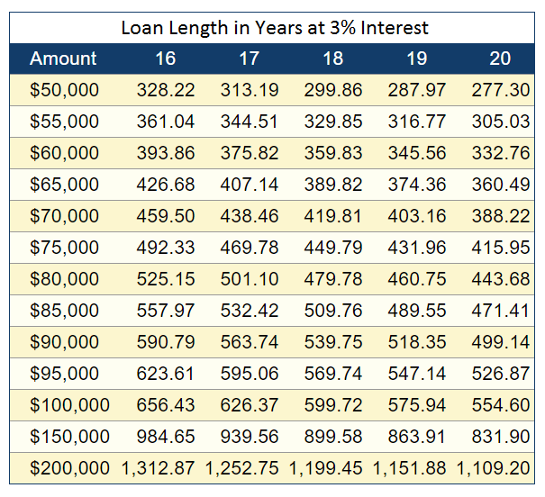
MID-LIFE CRISIS - WHERE ARE YOU GONNA LIVE?
Pick one!
Stay Where You Are | Buy Your First House | Time to Upgrade
Things are going fine and you see no need to move from where you are living - why rock the boat?  Question: You should probably start considering saving for your retirement. If you want to have $100 000 saved up for your retirement by the time you turn 65, how much would you have to contribute to an investment that pays 12% per year and is compounded bimonthly by age 40? How about at age 50?  Hint: The formula for compound interest is  A = P(1 + r/n)^{nt} where A is the final value of the investment, P is the principal or initial value of the investment, r is the interest rate per year as a decimal, n is the number of compounding periods per year and t is the number of years. | Your career is taking off and you decide to take the plunge and buy your first home.  QUESTION: Based on Fig. 2, what will be your monthly payment if you take out a $150 000 mortgage at 3% interest paid over 16 years? How much are you paying in total over the 16 years? How much are you paying in interest over the 16 years? | Your first home is starting to feel a little cramped; it’s time for an upgrade. You sell your old house and purchase a much larger home.  QUESTION: Assume you sold your old house for $150 000 purchased your new home for $300 000. How much will your new mortgage be? If your new mortgage has an interest rate of 3% and is paid out over 19 years, how much will your monthly mortgage payment be? How much are you paying in total over the 18 years? How much are you paying in interest over the 18 years?

OVER THE HILL - ENTERING RETIREMENT
Pick one!
Scaling Down | Moving in with the Kids | Move Somewhere Warm
You have a huge house and no one to fill it with. You decide to scale down to a smaller place and put that money towards making your retirement more comfortable.  QUESTION: You decide to sell your house for $180 000. Assume you’ll be kickin’ it for at least another 20 years. Which is the better financial decision for you?  - Rent a small apartment for a fixed cost of $800 a month.  - Buy a smaller house for $120 000. | Your kids are willing to take you in, granted you promise to babysit the grandkids.  QUESTION: You end up spoiling your grandkids; if you spend $50 a week on them, how much are spending per year? Over five years? | You decide to follow the example of the birds and head south.  QUESTION: You rent out a condo in Florida which will cost you $1000 per month plus annual condo fees of $3500. How much are you spending per year? Over five years?

Budget
Housing | Travel | Personal | Miscellaneous | Total Expenses | Total Income | Net
Calculation Page

Calculation Page

