Life in the Trenches of World War I
1914-1918

Learning Goals
By the end of this lesson, students will…
- Select and organize relevant evidence and information on aspects of Canadian history since 1914 from a variety of primary and secondary sources ensuring that their sources reflect multiple perspectives
- Interpret and analyze evidence and information relevant to their investigations, using various tools, strategies, and approaches appropriate for historical inquiry
- Use appropriate terminology when communicating the results of their investigations
- Identify some major developments in science and/or technology during this period, and assess their significance for different groups in Canada
Trench Routine
- Since the usual time for an enemy attack was at ___________, soldiers would wake then to guard the frontline trenches
- If there was no attack, they would gather for inspections, breakfast, and the daily __________ ration
- During the day, soldiers worked in their trenches doing a numbed of chores, ranging from cleaning latrines to filling sandbags or repairing duckboards
- In between chores, soldiers had time for leisure activities that included: __________________________, ____________________________, or ___________________________
- It was at _____________ ____________ that trench life was most dangerous as soldiers would move into No Man’s Land
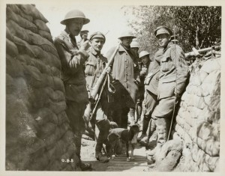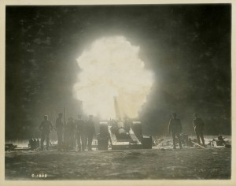
Trench Raids
- Patrols often occurred at ______________ under the cover of darkness; however, there was still a risk of injury, death, or capture
- There was also a risk of running into enemy patrols
- Raids could become _______________________ ____________________ if they were carefully planned and prepared for. These miniature battles would include the coordination of the raiding party with the machine gunners and artillery
- Raids kept soldiers in the trenches alert, motivated and aggressive, but they could also result in many ____________________________
Trench Weapons
- Trench warfare came about due to the increased firepower of _________________ ____________________, ________________________, and _______________________
- Once soldiers had dug into their trenches, a stalemate occurred on the Western Front and the only way to break that stalemate was to create greater weapons
- At the outbreak of war, most soldiers only carried a __________________ and a __________________________
- As the war progressed, soldiers became better equipped and began carrying grenades and utilizing mortars and machine guns in addition to their rifles and bayonets
- ____________________ _____________ and ________________ were also used to break into and out of enemy trench lines

Trench Newspapers
- Some units published their own ___________________________
- These newspapers were a way for soldiers to express their thoughts and feelings about the war
- The newspapers contained articles, poetry, jokes, and cartoons
- These newspapers were censored by the _____________________, but they were a safe environment for soldiers to reveal their anger about their hard life, although this was often done through the use of jokes
- There were over ___________ different Canadian trench newspapers during WWI and only few copies remain

Rest and Leisure
- Soldiers rotated into and out of the front lines to provide a break from the stress of combat
- Soldiers spend _______ to _______ days in the front trenches before moving back and spending an equal number of days in the secondary trenches and, finally, the reserve trenches
- Soldiers could go on an occasional leave to ________________________
- The ________________ hut was the centre of a soldier’s social life where they could read and write during the day, and attend concerts or lectures in the evening
- Sports also relieved the stress of war – __________________ was the most popular

Pests and Pain
- ______________ and ______________ infested the trenches and contributed to the spreading of diseases among soldiers
- Lice was found to be the cause of Trench Fever, which included headaches, fevers, and muscle pain
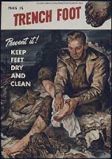
- The unsanitary conditions in combination with the cold weather and persistent dampness resulted in ____________________ _________________
- Trench Foot was a frostbite-like infection and in extreme cases led to gangrene and ____________________________________

Maintaining Morale
- Bonds of friendship, loyalty and community based on shared experience and common dangers promoted a strong sense of group identity
- Training, firm discipline, and strong leadership motivated soldiers
- The threat of _________________________________ kept soldiers in line
- Shared sense in the ________________________ of their cause
- The military attempted to provide simple pleasures like ________________________
- Letters arrived from home daily and on occasion care packages were sent as well
- _________________ was used for reward, medicine and motivation

Escaping the Trenches
- High casualties, poor food, and lack of sleep constantly threatened to undermine the __________________________ of soldiers in the trenches
- Soldiers that suffered from excessive stress (_______________________) may turn to desertion for which the punishment could be death by firing squad
- Some soldiers turned to ______________-_________________________ ____________________ (SIWs) - gunshot wound to the hand or foot, rubbing chemically infected soil in one’s eyes, etc.
- These soldiers with SIWs would be moved to a SIW hospital where they were liable to sentences that ranged from punishment to imprisonment
- There were ______________ cases of SIW in the Canadian Expeditionary Force, and many more that were likely undetected
- The actual number of soldiers who tried to escape trench life through illegal actions was _____________________
