Life in the Trenches
Anticipation Guide

Read over the following statements and state whether you believe they are True or False under the ‘Before Lesson’ column. At the end of class you will revaluate these statements and write whether they are True or False in the ‘After Lesson’ column.

Are these statements True or False?
Before lesson After Lesson

____ All soldiers would stand guard from dawn until dusk awaiting an attack ____
____ The Trenches were most dangerous during the day ____
____ Trench raids took place at night ____
____ Trench warfare came about due to the increased firepower ____
of machine guns, artillery, and rifles
____ At the outbreak of war, each soldier had their own personal machine gun ____
____ In the trenches, soldiers could only read newspapers sent from home ____
____ Newspapers were censored by the military ____
____ There were over 30 different trench newspapers ____
____ Soldiers had no time for leisure activities ____
____ The trenches were very clean and well kept ____
____ Severe cases of trench foot could result in amputation ____
____ Soldiers were not allowed to drink alcohol ____
____ Some soldiers attempted to escape the trenches by wounding themselves ____
____ The number of soldiers who tried to escape through illegal actions was large ____

Group Letter Activity
Group Members: _______________________________________________________________ _____________________________________________________________________________
_____________________________________________________________________________
_____________________________________________________________________________
In your groups elect one person to read the letter out loud to the rest of the group. Ensure everyone understands clearly everything that is stated in the letter. When everyone understands any confusing vocabulary or sentences continue with the following questions.
1. Why do you think receiving and sending letters were so important to the soldiers during the war? How do you think they would have felt to receive a letter on the western front? How do you think they felt writing and sending letters back home?
2. How does the soldier in the letter describe the conditions in the trenches? What kind of emotional strain has fighting and living in the trenches caused him? How would you describe his mood? Why do you think he feels this way?
3. What does he think of his chances of survival? How do you think he manages these feelings of potential death in battle?
4. He goes on at length about what he is being fed. Why do you think he spends so much time talking about these small details, compared to the horrors of the war?
5. He mentions that his wife has sent him three boxes of stuff, but he fears that two boxes have gone missing. Imagine how you would feel if you didn’t receive items sent to you from home? How might you express your frustration?
6. What are some of the things he mentions about home? What does he miss? What would you miss about home if you were away for several years fighting in a war?
7. Discuss the impact living in these trenches for many years might have on a solider? What emotional scars might they have? What physical problems might they have? Do you think the soldiers who were lucky to return home to their families were the same people? How might the war have changed them?

World War I – Letter Assignment Due Date:_____________________
YOU ARE TO PRETEND THAT YOU ARE CANADIAN SOLDIER* FIGHTING IN THE TRENCHES ON THE WESTERN FROM DURING WWI. YOUR ASSIGNMENT IS TO WRITE A LETTER HOME AND ASSUME THAT IT HAS SOMEHOW PASSED CENSORSHIP. (*YOU COULD ALSO ASSUME THE ROLE OF A NURSE) THE LETTER SHOULD USE FACTS TO HELP CREATE A VIVID IMAGE OF WHAT THE WAR EXPERIENCE WAS LIKE. IT SHOULD ALSO AIM TO ILLUSTRATE THE EFFECTS OF NEW TECHNOLOGY ON THE WAY WAR WAS FOUGHT. FINALLY, IT SHOULD HAVE A PERSONAL FEEL, REFLECTIVE OF A LETTER WRITTEN DURING WARTIME.

Here is a breakdown of how it should be done to successfully complete this assignment:
KNOWLEDGE & UNDERSTANDING The fact base of your letter must include the following:
A minimum of 5 solid facts of your choice including details on the following:
- One major battle (Canadians were involved in)
- One new type of weaponry
- Life in the trenches
- Conditions in the trenches- mud, lice, rats, dead bodies, etc.
- Comments on the diet of a Soldier
- Key person (e.g. name of a commander, war hero, etc)
*Be sure that your factual data is appropriate and accurate for the date that you choose to write on
THINKING & INQUIRY: The letter must also include:
- What you thought of the war before you began fighting and after
- A description of your feelings and emotions based on your “experiences”
- An explanation of how new technology (military machinery) has effected your life
- Your reasons for enlisting

COMMUNICATION:
- The letter should be written using proper paragraphs
- Aim to move towards a more sophisticated vocabulary & use of a complex sentence structure
- Be sure to proofread carefully for spelling and grammatical errors
APPLICATION:
- Your work should be written in a letter style (which would include elements like a date, who the letter is written to and signature at the end)
- Be sure to include some of the vocabulary terms that you have learned
- Aim to incorporate the facts you have selected smoothly into your letter so that they do not sound too forced
- Try to give your letter a personal feel

PROCESS:
- Be sure you have read this entire sheet carefully
- Use your class notes, handouts provided, scrapbooks, your texts and reputable internet sites to gather data to assist you in completing this assignment. Start by making rough notes on the information you will need to create your letter. Remember to aim to include specific details and examples in your note taking
- Once note taking is complete, start your rough draft. Proofread, revise and polish
- Highlight all facts on your rough draft to ensure you have covered the required elements. Next, in another colour, highlight the parts of your letter where you have described your feelings on war, your emotions and the effect of technology on your fighting experience
- Finally, complete your good copy
- Hand in your research notes, a rough copy, a good copy of the letter and this sheet to your teacher
Here are a couple of websites that may be useful:
- www.vac-acc.gc.ca/general/
- http://www.archies.ca/05/0518_e.html
- http://www.bbc.co.uk/history/3d/trench.shtml
- http://worldwar1.com/reflib.htm
- http://spartacus.schoolnet.co.uk/FWWtrench.htm
- http://firstworldwar.com

The Gas Mas Activity
Group Members: _______________________________________________________________ _____________________________________________________________________________
_____________________________________________________________________________
_____________________________________________________________________________
The First World War saw the introduction of many innovative and horrible means to kill one's enemies. At the forefront of these was the use of poison gas, which was first deployed by the Germans in the form of Chlorine Gas, but then quickly adopted and put to use by all sides with varying degrees of success. Chlorine gas killed its victims by asphyxiation. A field report by Major Karl von Zingler, described the first chlorine gas attack by German forces which took place before January 2, 1915: "In other war theaters it does not go better and it has been said that our Chlorine is very effective. 140 English officers have been killed. This is a horrible weapon...."
Gas was not a terribly efficient weapon; there are multiple cases of wind shifts causing the gas to blow back towards its user, but it did have the notable effect of producing sheer terror in the trenches. Cluny MacPherson, a Canadian military Doctor with the Newfoundland Regiment, created the first effective gas mask.
Take turns trying on the mask.
1. What issues do you notice that arise when wearing the mask?
2. Make a list of the positive and negative aspects of the gas mask and its use.
3. What are your thoughts on the use of gas in warfare? From a military perspective, was it a good idea to use gas?
4. Was it ethical? Why or why not?
5. Complete the following Concept Circles by circling the word that does not belong and naming the concept.
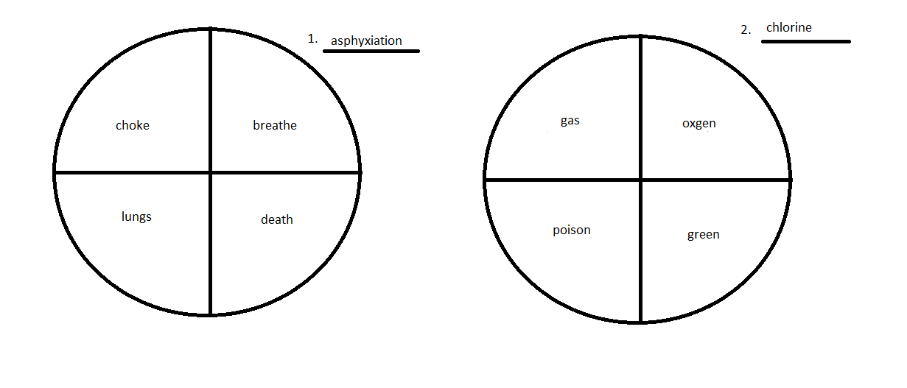

The Gas Mask: Group Assignment
In your group research an actual account of a chemical gas attack in the trenches and prepare a short skit (5 minutes) dramatizing it. You may also film the skit if you are more comfortable with that. This exercise is intended to be a realistic glimpse into the life of a soldier in the trenches – be sure to use other elements from class to flesh out the story i.e. vermin and lice, trench foot, boredom, bad food etc. The script should be submitted on the day of the presentation. It should also include a short synopsis covering: Who was involved, What happened, When and Where this occurred, as well as How you would feel if you were placed in this situation.

Trench Maps: 3D Model Activity
Group Members: _______________________________________________________________ _____________________________________________________________________________
_____________________________________________________________________________
_____________________________________________________________________________
Visualizing Life in the Trenches

Distribute a dossier with photographs, diagrams and trench maps on WW1 trenches. Ask the students to examine the documents and answer the following questions:

- Identify the types of documents in your dossier.
- What do these documents tell us about life in the trenches during WW1?
- What do these documents tell us about how trenches where constructed?
- Based on these documents, what materials do you think soldiers use to build trenches?
- Identify the main features of a WW1 trench: the wire obstacle, barbed wire tangle defense line, front line trench, the parapet, the sand bag wall, and the revetment.
• Imagine that your group is planning an attack. In order to ensure success and minimize casualties you will need to create a 3D model of the enemies trenches from these documents. How could you use these documents to build your model? What are the important features that you will need to indicate on you model?

Trench Maps Assignment

Working in their group students will construct a 3D model of a WW1 trench using modeling clay and any other materials that they think will help illustrate their diorama. They will have to label their models, indicating the main features of a WW1 trench that they identified during their in-class activity.

Assessment

Does the model include all of the main features of a WW1 trench that they were asked to identify during their initial in-class activity?

How much detail have they incorporated into their model?

Does their model indicate that they have analyzed and interpreted the documents that they where provided with during their in-class activity?

Historical Photograph Activity

Group Members: __________________________________________________________________ ________________________________________________________________________________________________________________________________________________________________________________________________________________________________________________________________________________________________________________________

As a group, examine the historical photograph and answer the following questions. Assign one member to jot down the answers on a separate sheet of paper, as you will be sharing your findings with the class. Be sure to correctly number the answers to the corresponding question.

1. What is happening in this image?
2. Are there people in the photograph?
a. If so, what are they doing?
b. What are their expressions?
c. What are they wearing?
3. What objects are in the photograph?
4. What is the relationship between the people and the objects?
5. Why is the image important to history?
6. What is the mood of the photograph?
7. How does it make you feel?
8. Where is your eye drawn when examining the photograph?
9. Is the photo spontaneous or posed?
10. Where do you think this photograph was taken?
11. What questions does this photo raise?
12. Can you connect the photo to what you have learned thus far about World War I and Life in the Trenches?

Photo Scavenger Hunt Assignment

To show your understanding of the life of a solider in WWI and to expand your knowledge on the topic, you will find 5 images on the internet that will match up to the categories listed below. In addition, you will write a description that will explain and state the significance of each image. Finally, you will provide a citation for each image to prove where you found the image.

Image Categories
Choose 5 of the following 10 categories and find an image that fits well with that category. If there is a category that is of interest to you that is not listed, please consult the teacher before using the category.
1. Find an image that depicts daily life in the trenches of WWI.
2. Find an image that depicts mealtime in the trenches of WWI.
3. Find an image that depicts weapons used in trench warfare.
4. Find an image that depicts hygiene practices in the trenches of WWI.
5. Find an image that depicts disease in the trenches of WWI.
6. Find an image that depicts animals in the trenches of WWI.
7. Find an image that depicts comradeship in the trenches of WWI.
8. Find an image that depicts the horrors of life in the trenches of WWI.
9. Find a cartoon image that represents life in the trenches of WWI.
10. Find a propaganda image that depicts life in the trenches of WWI.

When writing the description for each image, please answer the following questions in a concise paragraph. You are encouraged to consult your notes.
- Why does the image fit into the category you chose?
- What is happening in this image?
- Are there people in the photograph? If so, what are they doing? What are their expressions?
  - What are they wearing?
- What objects are in the photograph?
- What is the relationship between the people and the objects?
- Why is the image important to history?
- What is the mood of the photograph?
- How does it make you feel?
- Where is your eye drawn when examining the photograph?
- Is the photo spontaneous or posed?
- Where do you think this photograph was taken?
- What questions does this photo raise?
- Can you connect the photo to what you have learned thus far about World War I and Life in the Trenches?
When completing the citations for each photograph, please use MLA format. You may use this website as a guide: https://owl.english.purdue.edu/owl/resource/747/05/

Image Checklist
- I have chosen 5 different categories
- I have chosen 1 image per category
- I have answered all of the listed questions when writing the descriptive paragraph for each image
- I have used proper paragraph structure, including: the topic sentence, body sentences, and concluding sentence
- I have provided a citation for each image using the correct works cited method

