1876 Indian Act – Introduction and Origins

“The Indian Act in Canada… is much more than a body of laws that for over a century have controlled every aspect of Indian life. As a regulatory regime, the Indian Act provides a way of understanding Native identity, organizing a conceptual framework that has shaped contemporary Native life in ways that are now so familiar as to almost seem ‘natural’”
- Bonita Lawrence

Introduction
- The Indian Act is a federal Canadian law that oversees matters including Indian status, bands, and reserves
- Has a reputation for being both paternalistic and invasive
- Has gone through many amendments since its original introduction, but in many ways, it still remains similar to its beginnings
- Administered by Indian and Northern Affairs Canada (INAC), formerly the Department of Indian Affairs and Northern Development (DIAND)
- Primary goal is assimilation of First Nations with the intent to end cultural practices and the distinct elements of First Nations culture, economics, and politics by fully immersing them into mainstream Canadian life, culture, and values
- Since its introduction, First Nations people have continuously resisted the oppression that they face and have active protested to establish and protect their rights

Origins
- Since its initial introduction, the goal was to assimilate First Nations people into mainstream Canadian society
- Its roots are found in other acts, including the Gradual Civilization Act of 1857 and the Gradual Enfranchisement Act of 1869

Key Terms
- Indian status – the legal identity of an Aboriginal person
- Bands – basic unit of governance for those subjected to the Indian Act
- Reserves – areas of land set aside for solely Aboriginal use
- Paternalistic – The Indian Act is considered to be paternalistic because it gives the federal government of Canada to both regulate and administer the lives of both registered Indians and those that are living in designated reserve communities. The extent of the government involvement has ranged from broad political control to involvement, and occasionally obstructing, the right to partake in cultural traditions and practices. It also authorizes the federal government the ability to decide who is qualified for Indian status.
- Gradual Civilization Act of 1857 – goal was assimilation through enfranchisement (though only one person voluntarily enfranchised, causing the act to be sometimes considered a failure)
- Enfranchisement – the legal process of giving up one’s Indian status in favour of full Canadian citizenship. This was introduced in the Gradual Civilization Act of 1857
- Gradual Enfranchisement Act of 1869 – required the “enfranchisement” of male Indians over 21 able to speak, read, and write in either English or French. An enfranchised Indian would then be considered a regular Canadian citizen instead of an Indian
Indian Act – Potlatch Law, Section 141, and 1951 Amendments

The Potlatch Law & Section 141
- In 1884, the federal government banned potlatches, believing them to be “excessive and wasteful” as well as delaying assimilation into mainstream Canadian culture
- Many First Nations tried to resist this ban, and many were arrested or had to give up their traditional potlatch items, leading to a massive cultural loss, as a result
- In the 1920s, Aboriginal resistance had taken the form of political organizations. As a result of this, Section 141 was added to the Indian Act by the federal government
- Section 141 prohibited First Nations from hiring lawyers and otherwise using the legal system to maintain and/or gain rights.
- These changes proved to be a significant obstacle for First Nations people, as many organizations that they had formed, including the League of Indians, were unsuccessful

1951 Amendments
- The events of the Second World War led to a rising concern about human rights and a growing realization that Canada’s First Nations were among those most disadvantaged
- The Indian Act was revised in 1951, and the sections that were most oppressive to First Nations were taken out
- This amendment meant that the First Nations practicing their cultural customs, such as the potlatch, was no longer illegal
- Other changes included permission to gamble, to enter pool halls, to wear cultural dress outside of the reserves, to organize and hire legal council, and for women to vote in band councils
- Despite all of these changes, there were still restrictions on the consumption of alcohol
- The purpose for these changes was to allow First Nations to contribute to Canadian society rather than be outcasts from it

Key Terms
- Potlatches – significant ceremonies for First Nations in the west, often considered critical for the distribution of wealth and one of the most important cultural traditions
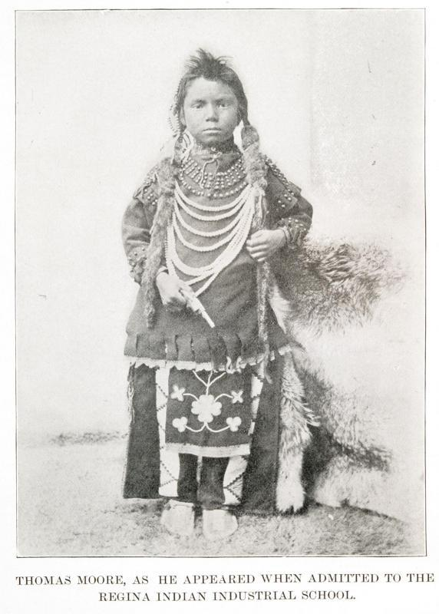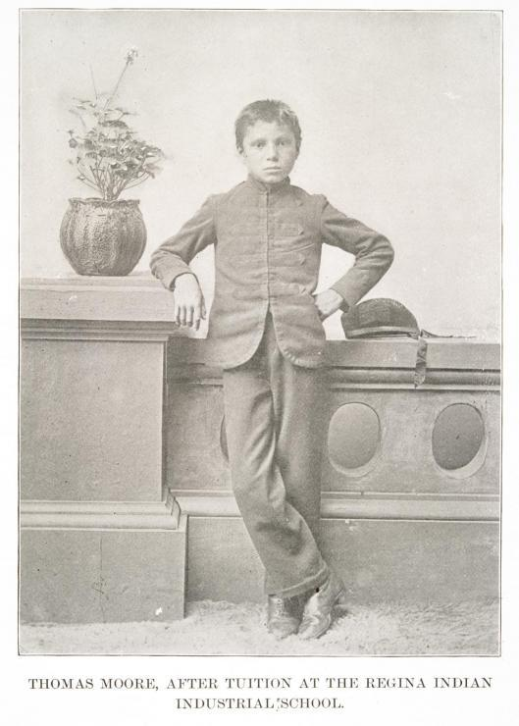
Indian Act – The White Paper, Bill C-31, and Gender Discrimination

The White Paper
- In 1969, a “white paper” policy was proposed by Prime Minister Pierre Trudeau; the purpose for this was to for the First Nations to experience greater equality within Canada
- This policy proposed to abolish the Indian Act in its entirety, as well as the Department of Indian Affairs, believing that this would allow First Nations people to become more like other Canadian citizens
- This policy faced widespread resistance from Aboriginal peoples throughout the country, as they did not believe that abolishing the Indian Act was the means to achieving equality. Instead, they wished to keep their legal distinction as Indian people in Canada.
- The strong rejection of the white paper policy led to its abandonment by the federal government
- It has been argued that the abandonment of this policy led the government towards protecting rights for First Nations people rather than advocating for assimilation

Bill C-31 and Gender Discrimination
- Among the other controversies, the Indian Act has also been criticized for its gender bias
- For example, Indian Act legislation stated that a woman would lose her Indian status if she married a man that was not considered Indian. Losing her Indian status would mean losing treaty and health benefits, the ability to live on her reserve, the ability to receive family inheritances, and the right to a reserve burial.
- Despite all these limitations placed on women, an Indian man marrying a woman without Indian status would still have all of his rights.
- If a woman married a man with Indian status that was a member of another band, she would become a member of his and lose membership in her own.
- If a woman was abandoned or widowed, she would be enfranchised, leading to the complete loss of her Indian status.
- In each of the above described situations, a woman’s Indian status is entirely dependent on her husband. This reality led to a 1970s movement to change the legislation.
- The first attempt, by Jeanette Corbière Lavalle and Yvonne Bedard in 1979, was lost at the Supreme Court. A second attempt, by Sandra Lovelace in 1981, was taken to the United Nations, and the United Nations Human Rights Committee found Canada in breach of the Covenant on Civil and Political Rights
- In 1985, Bill C-31 was passed, which allowed those who had lost Indian status through the previously mentioned means to regain it
- This amendment remains controversial, since those who have regained Indian status are only able to pass it on for one generation. This challenge was brought to the Supreme Court of British Columbia in 2009 and ruled as unconstitutional (as it violates rights of equality), and the Indian Act is in the process of an additional amendment.

Key Terms
- Enfranchised – the legal process of giving up one’s Indian status in favour of full Canadian citizenship. This was introduced in the Gradual Civilization Act of 1857
Indian Act – Should the Indian Act be Abolished?

- Some groups believe that the Indian Act violates human rights and believe that the federal government does not have the ability to rid Aboriginals of their rights, even though this was legal until 1985 through the process of enfranchisement.
- However, the Indian Act holds significance to First Nations people, particularly legally and historically; this contributes to the strong resistance that government officials have been met with during attempts to abolish it (including the 1969 proposition of the white paper policy).
- In summary, the Indian Act provides a legal distinction between First Nations and the rest of Canadians, and it also recognizes that the Canadian federal government has an obligation to First Nations people and their rights. However, the federal government has also been the body to make changes to this important act without consulting those that it impacts.
- Without a doubt, the Indian Act has been and remains a very controversial part of Canadian legislation. Although there are a wide variety of opinions about the future of the Indian Act, many agree that the First Nations people must be a key part of it.

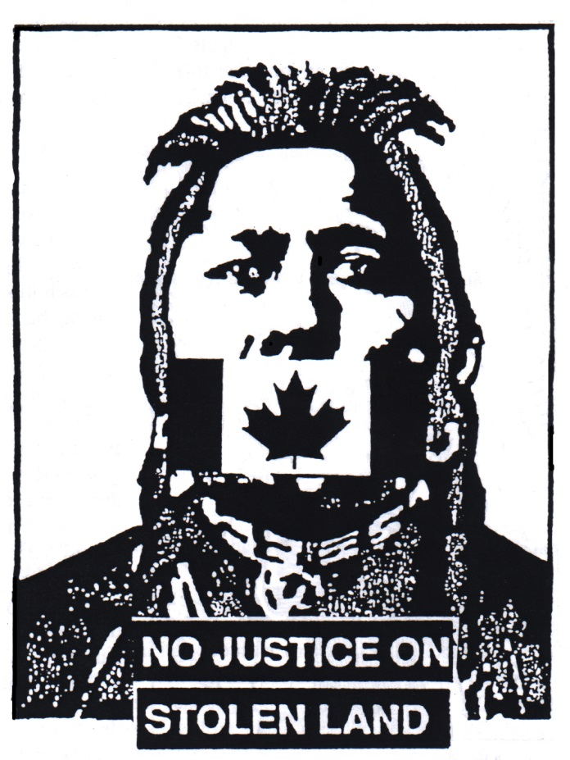

Living Conditions at Residential Schools

- Aboriginal children were required to attend residential schools if they were between the ages of 7-16 after a 1920 amendment to the Indian Act.
- If parents did not comply by sending their children to one of these schools, they were often punished, occasionally through imprisonment.
- Since the 1920 amendment made attendance mandatory, many children were forcefully separated from their parents and removed from their homes, often to travel great distances away.
- Even children that lived within a close proximity to a residential were often forbidden to see their families.
- If siblings were students at the same school, they were often separated.
- A study done in 1950 stated that over 40% of the teaching staff employed at residential schools had no professional training.
- The quality of education was much lower for students in residential schools than students in other Canadian schools.
- English was the language of instruction within residential schools, and children were forbidden to speak their cultural language(s).
- Many residential schools were run by churches/church groups; Christian religious values were emphasized, and Aboriginal spirituality was condemned.
- Many students in residential schools suffered from many forms of abuse, including sexual, physical, mental, emotional, and neglect.
- Some forms of abuse endured by Aboriginal children include beatings, bondage, confinement, forced labour, overcrowding, illness and disease, hunger and thirst, participation in medical experiments, being fed rotten food, and occasionally death.
- Many schools also required the students to do housework or manual labour in order to reduce the operating costs.
- While in the schools, students were not permitted to speak their language or culture. If they did so, they were often severely punished.
- Although residential schools are no longer in operation, the impact still remains. The conditions that children endured resulted in lingering feelings of shame, trauma, and neglect. In addition, the loss of family, language, culture, and identity have been felt for generations.
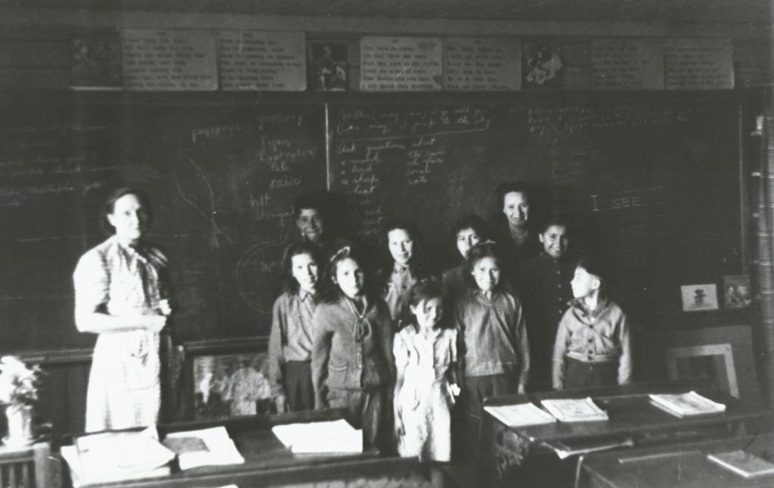
School Profile 3: Old Sun’s Boarding School

The Old Sun’s Boarding School began as a school that was established on the Siksika Nation in Southern Alberta by the Canadian federal government and the Anglican Church in 1883. It began as a small building that students attended only during the day but later became a full-time residential school called the Old Sun’s Boarding School.

Although the government said that the conditions of the school were desirable, in truth they were no better than most of the other residential schools. They were small, overcrowded, and poorly-built. The school was initially built to accommodate twenty five to thirty students but quickly enrolled even more. Once the students were enrolled, most of them continued to attend until they were eighteen years old.

In theory, children were sent to the Old Sun’s Boarding School in order to study and to learn how to prepare for life as fully-assimilated and educated Canadian citizens; the reality, however, is that many students did not have the chance to excel at school and instead engaged in industrial work. When the students did attend classes, their supplies were limited: they only had access to a few books and worn-down pieces of furniture, all of which were still the property of the government.

Students at Old Sun’s Boarding School were not called by their Aboriginal names; they were renamed with more typically Canadian names and were not allowed to continue to practice their own religions or other cultural beliefs. They were also often referred to by their assigned student numbers rather than by any name. The children were isolated from their friends, family, and social communities once they arrived at the school. Many parents tried to remain in contact with their children while they attended the schools but were often unsuccessful. Some children tried to run away from the school but were also unsuccessful.

Many children at the school became sick easily; once disease or illness were in the school, they spread quickly among the students. Severely ill students were sometimes sent back to their homes, where they would infect their families and continue to spread the illness. From 1894-1897, approximately 11 children died at the school.

Although the government tried to advertise the benefits of the Old Sun Boarding School, the firsthand pieces of research and survivor accounts that exist today prove that the school was, in fact, an extremely unpleasant place to live.

‘This is not just an aboriginal issue. This is a Canadian issue’

The commission hearing of abuses at native residential schools takes its message to heart of Bay St.
By: Peter Edwards Staff Reporter, Published on Fri Jun 10 2011
There’s no exact tally, but hundreds of First Nations children disappeared after being taken from their homes to attend residential schools from 1870 to the mid-1990s.
That’s the most startling discovery for Murray Sinclair, the Manitoba judge who is chair of the Truth and Reconciliation Commission examining the effects of residential schools on First Nations communities.
“Missing children — that is the big surprise for me,” Sinclair said in an interview during a Toronto visit this week. “That such large numbers of children died at the schools. That the information of their deaths was not communicated back to their families.”
Commission staff are still gathering information on how many aboriginal students died while attending, or attempting to escape from, the church-run schools, but the number is believed to be somewhere in the hundreds.
Sinclair and commissioners Chief Wilton Littlechild and Marie Wilson and staff have visited hundreds of communities across Canada affected by residential schools since they began their work in 2009, and they plan to visit hundreds more before their mandate runs out in 2014.
The commission was born from the Indian Residential School Settlement Agreement, the largest class-action settlement in Canadian history.
It has the responsibility of honouring the lives of former students and families affected by the schools, educating the public and creating a permanent record.
This week, Sinclair was in Toronto, where he had a Bay St. breakfast meeting with power brokers from universities, the media, business and banking at the National Club.
Sinclair said it’s important for the story of the schools to reach across the country, from our educational system to the corridors of corporate power.
Development in aboriginal communities and treaty settlements have left some communities with multi-million dollar funds, and an interest in better business relations.
“For them to understand and appreciate the client that they’re dealing with, I think they need to understand this history,” Sinclair said.
“This is not just an aboriginal issue. This is a Canadian issue. This is a Canadian problem.”
Sinclair wanted the breakfast group to appreciate the widespread dysfunction that resulted after 150,000 First Nations, Métis and Inuit children were taken from their families to attend more than 130 residential schools across Canada from 1870 to 1996.
Siblings were often separated. Native languages, customs and religious ceremonies were forbidden, and parents and relatives were discouraged from visiting.
Sinclair and others in the commission have heard searing stories of sexual and physical abuse from nuns and priests, and how the crowded schools were sometimes rife with fatal diseases like tuberculosis.
The timing of the National Club visit is significant. Saturday is the three-year anniversary of Prime Minister Stephen Harper’s apology to First Nations communities for the schools, in which he said the goal of schools was often “to kill the Indian in the child.”
“We now recognize that, in separating children from their families, we undermined the ability of many to adequately parent their own children and sowed the seeds for generations to follow, and we apologize for having done this,” Harper said in his apology.
There are some 80,000 survivors of residential schools still alive in Canada, and their average age is over 65. Sinclair commended Harper’s apology, but said there is plenty of work to be done, which will likely take generations to correct.
Sinclair, Manitoba’s first aboriginal judge, didn’t have to travel outside of his home community on the St. Peter’s reserve near Selkirk, Man., to hear about the ill-effects of the schools.
While he didn’t attend a residential school himself, his aunts, uncles, cousins, father, and plenty of others from St. Peter’s did.
He said he found the National Club breakfast group receptive and wanting to help in healing.
Sinclair said he told them that it took seven generations for things to reach their current state, and they shouldn’t expect a quick fix.
The fact that the meeting was held and positive is a victory in itself, he said.
“Twenty years ago, we never would have had a breakfast like this. Nobody would have come. We wouldn’t have even thought of inviting them.”
“There’s is this view that this was a good project gone bad. It was a bad project form the beginning.”

School Profile 2: Cristal Lake Residential High School

Cristal Lake Residential High School was established in 1976 in remote Stirland Lake in Northwestern Ontario to house female Aboriginal students. It was in a very isolated location of the area and was only accessible by float plane.

In 1986, the school merged with the all-male residential Stirland Lake High School. Both schools were very small initially but steadily increased in size as the years went on. Once the schools had amalgamated, they were both known under the Stirland Lake High School name, and their coed student population steadily grew.

Like all of the other educational institutions at the time, Cristal Lake Residential High School had a strong Christian religious influence. The daily living conditions were grim and similar to many of the other schools. Due to the incredibly remote location of the school, the students had minimal interaction with people outside of the institution.

The school was ultimately closed in 1991.
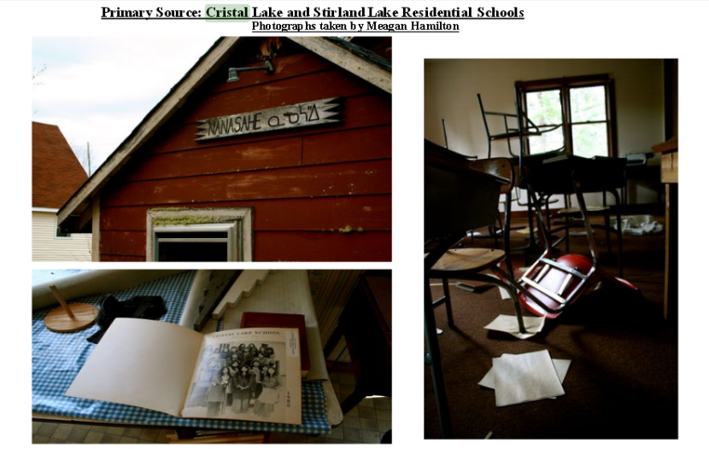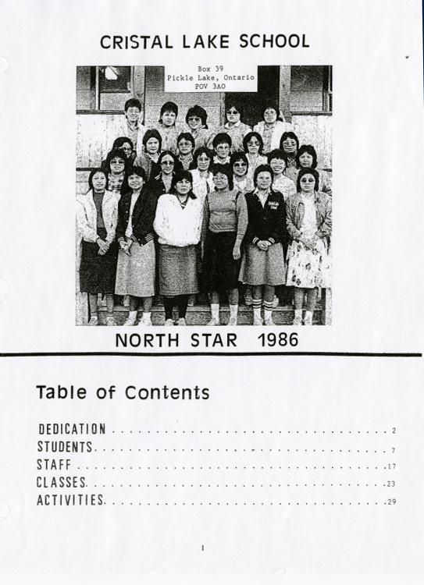
Major Amendments to the Indian Act

The Indian Act was changed frequently, and the Aboriginal people who it affected were almost never consulted about the changes. Although Aboriginal people viewed the Act as a binding contract, the government saw it as a lax “promise” that could easily be altered or broken.

Although there have been dozens of revisions and amendments made to the Indian Act, the major amendments have been listed here:

- 1885: Most traditional Aboriginal ceremonies, such as potlatches, are prohibited
- 1894: Band control over non-Aboriginals living on reserves are removed and given to the Superintendent General of Indian Affairs
- 1905: Aboriginal people living on reserves near towns with more than 8 000 people can be forced to leave
- 1911: Government is allowed to use portions of reserves for roads, railways, and other public works or, in some cases, to seize and use an entire reserve for similar purposes
- 1914: Aboriginal people are required to obtain permission before appearing in public dances, exhibitions, or shows in traditional Aboriginal dress
- 1918: Government can lease out reserve lands to non-Aboriginal people for farming or pasture
- 1920: Every Indian child from ages seven to sixteen is required to attend a residential school; graduates from the schools can be enfranchised, even if they do not agree to the process
- 1927: Soliciting funds for Aboriginal legal claims with permission from the Superintendent General is illegal; it is also illegal for Aboriginal people to form political organizations
- 1930: Pool hall owners are allowed to ban Aboriginal men who are deemed to be problematic
- 1936: Government officials were allowed to direct Indian band council meetings and, in the event of a tie, to vote on major decisions
- 1951: Indians allowed to sell and slaughter livestock without a permit from the Indian agent
- 1985: Enfranchisement process is voided
- 2000: Band members living outside of reserves can vote in band elections and referendums
- 2011: Gender Equity in Indian Registration Act is added
- 2013: The Transfer of Land in an Indian Reserve form is published

School Profile 1: File Hills Indian Residential School

File Hills Indian Residential School was open from 1889 until 1949, when it became so overcrowded that it was considered to be a major fire hazard. The school was run primarily by the Women’s Missionary Society of the Presbyterian Church initially, but after 1925, it was also run by the United Church of Canada.

The school was located just outside the boundaries of the File Hills Agency Indian reserve in Saskatchewan. It began as a day school that attracted little interest at first. It later became a boarding school, and mandatory attendance was rigidly enforced.

Education was not a priority in the rural community. Male students were forced to participate in agricultural work and dairy farming; female students were taught to sew, cook, and clean. As a result, the students spent less and less time in class as they grew older and fell behind in their studies.

Students at File Hills Indian Residential School were not treated kindly but were punished often. The quality of food was acceptable but there was never enough of it, so students would often resort to stealing food or hunting small animals to feed themselves.

Students were often sick and, since they lived together, illness spread quickly through the school. In the winter of 1908, two girls died there from tuberculosis.

The building was often overcrowded, in need of repair, and missing sufficient staff numbers. The day-to-day conditions were miserable at best.

When the school finally closed in June of 1949, the remaining students were all sent to continue on at other residential schools in Canada.
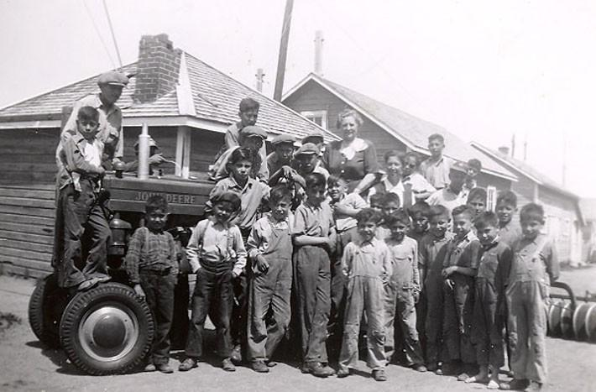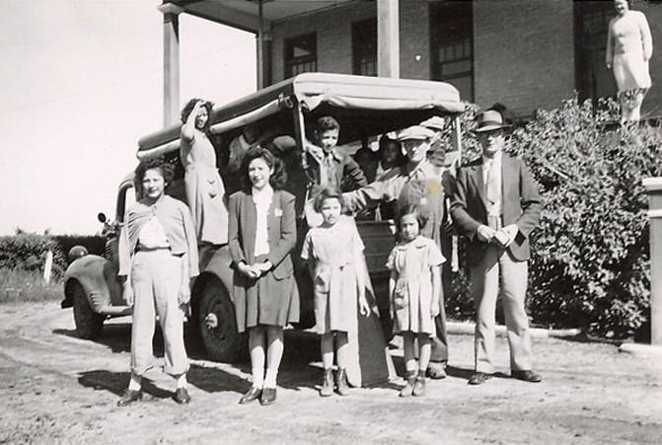

Residential Schools: Facts and Statistics

- The first residential schools in Canada were created in the mid nineteenth century (1850)
- Initially, about 1 100 Aboriginal students attended 69 different schools
- 1931 was the peak year for residential schools in Canada: there were 80 different schools operating by then
- Children from the ages of 4-16 attended the schools
- In 1907, Indian Affairs’ Chief Medical Officer, Dr. P.H. Bryce, reported a death toll among the schools’ children ranging from 15-24%
- Widespread occurrences of disease, hunger, and overcrowding were noted in the schools by government officials as early as 1897
- In 1930, only 3 out of 100 Aboriginal students advanced past grade six in the school system
- During the 1940s and 1950s, many students were put into nutritional experiments that resulted in malnourishment; they were never asked to consent to the experiments
- Over the course of the entire system, there were more than 130 schools in existence (although they were not all being run at the same time)
- In total, around 150 000 children were taken away from their families and forced to attend these schools
- Many of the schools that children initially attended during the day only were eventually changed into boarding schools
- In the 1980s and 1990s, several churches apologized publicly for their parts in supporting the schools
- It was not until the 1990s that the Canadian government began to formally acknowledge and try to make amends for what had been done to Aboriginal children in residential schools
- The last residential school in Canada did not close until 1996
- In 2007, the Canadian government created a compensation package for Aboriginal people who could prove that they had lived in residential schools in Canada
- Most were eligible to receive $10 000 for their first year spent in the schools and $3 000
for subsequent years
- In June 2008, Prime Minister Stephen Harper delivered a formal apology to Aboriginal people for the actions of the Canadian government in regards to the residential school system
- Since June 2008, several events have been held that allow survivors of the Canadian residential schools to share their stories of their times in the system
- Today, it is estimated that there are almost 80 000 living survivors from the Canadian residential school system
- In April 2009, Pope Benedict XVI offered an apology to a group from Canada’s Assembly of First Nations

Sources

http://www.cbc.ca/news/canada/a-history-of-residential-schools-in-canada-1.702280
http://indigenousfoundations.arts.ubc.ca/home/government-policy/the-residential-school-system.html
http://wherearethechildren.ca/stories/
http://wherearethechildren.ca/timeline/
http://www.trc.ca/websites/trcinstitution/index.php?p=4
http://www.anishinabek.ca/irscp/irscp-about-residential.asp
https://www.aadnc-aandc.gc.ca/eng/1100100015576/1100100015577
http://thechildrenremembered.ca/school-locations/file-hill/
http://opentextbc.ca/geography/chapter/4-4-case-study/
http://mapleleafweb.com/features/the-indian-act-historical-overview
http://archives.algomau.ca/main/taxonomy/term/1180
http://www.theodorechristou.ca/tmc/Select_Subjects_in_the_History_of_Ontario_Education_files/The%20History%20of%20Aboriginal%20Education%20in%20Ontario.pdf
http://www.thestar.com/news/canada/2011/06/10/this_is_not_just_an_aboriginal_issue_this_is_a_canadian_issue.html
http://www.mfnerc.org/wp-content/uploads/2012/11/4_SheilaJane.pdf
http://timeline.knightlab.com/
http://www.trc.ca/websites/trcinstitution/index.php?p=4
http://www.afn.ca/index.php/en/policy-areas/indian-residential-schools
http://www.cbc.ca/news/canada/a-history-of-residential-schools-in-canada-1.702280
http://www.afn.ca/index.php/en/policy-areas/indian-residential-schools
https://warriorpublications.files.wordpress.com/2012/08/no-justice-stolen-land-logo1.jpg
Quotations

“Sister Marie Baptiste had a supply of sticks as long and thick as pool cues. When she heard me speak my language, she’d lift up her hands and bring the stick down on me. I’ve still got bumps and scars on my hands. I have to wear special gloves because the cold weather really hurts my hands. I tried very hard not to cry when I was being beaten and I can still just turn off my feelings…. And I’m lucky. Many of the men my age, they either didn’t make it, committed suicide or died violent deaths, or alcohol got them. And it wasn’t just my generation. My grandmother, who’s in her late nineties, to this day it’s too painful for her to talk about what happened to her at the school.”
- Musqueam Nation former chief George Guerin, Kuper Island school
Stolen from our Embrace, p 62
“We feel that the acceptability of the apology is very much a personal decision of residential school survivors. The Nisga’a Nation will consider the sincerity of the Prime Minister’s apology on the basis of the policies and actions of the government in the days and years to come. Only history will determine the degree of its sincerity.”
- Kevin McKay, Chair of the Nisga’a Lisims Government, June 12, 2008

“We are on the threshold of a new beginning where we are in control of our own destinies. We must be careful and listen to the voices that have been silenced by fear and isolation. We must be careful not to repeat the patterns or create the oppressive system of the residential schools. We must build an understanding of what happened to those generations that came before us.”

Wayne Christian, Behind Closed Doors: Stories from the Kamloops Indian Residential School, 2000
“This is not just an indigenous issue. This is a Canadian issue.”
- Murray Sinclair (Manitoba judge)
“I want to get rid of the Indian problem. I do not think as a matter of fact, that the country ought to continuously protect a class of people who are able to stand alone… our objective is to continue until there is not a single Indian in Canada that has not been absorbed into the body politic and there is no Indian question, and no Indian Department.”
- Duncan Campbell Scott (Department of Indian Affairs)
“The meals were not bad although we never got enough to eat, especially when we had to work half a day, sawing wood, cleaning barns, digging potatoes, any kind of harvesting and planting. We used to steal anything to eat, we’d even run for miles on a Saturday afternoon to raid homes for a bit of food…On Saturday afternoons we’d slip over the page wire fence to hunt rabbits or partridge, we would then have a feast with our kill. We used sling shots as our weapons which were strictly illegal. At times we would even eat grey squirrels. This was one of our fun times in school.”
- former student reflecting on his experience at File Hills IRS in the 1930s (see School Profile 1)

