Scrapbook on Residential Schools in Canada

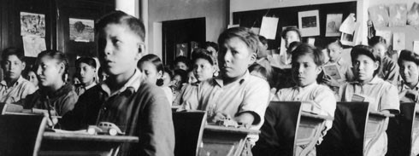
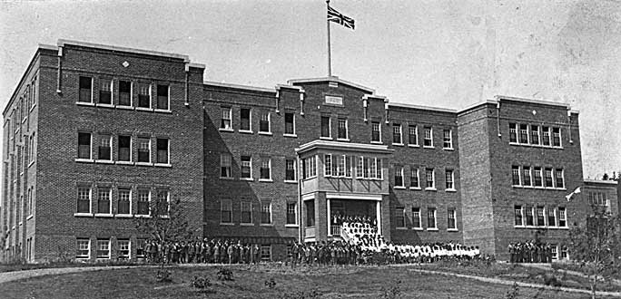

Risa Hlymbicky, Angelica Lachance, Ruxandra Nahaiciuc

