Criteria | Grade |  |  |  | Comments
 | 1 | 2 | 3 | 4
Thinking/Inquiry | No evidence that the student understands the method to naming functional groups.  The student cannot distinguish between different groups and cannot name different physical properties. | Some evidence that the student understands the method to naming functional groups. The student somewhat distinguishes between different groups and can name few physical properties. | Evidence that the student understands the method to naming functional groups. The student can distinguish between different groups and can name most physical properties. | Detailed evidence that the student understands the method to naming functional groups. The student can distinguish between all different groups and can name all physical properties
Application | Does not apply appropriate use of naming, no creativity, little detail provided, and failure to use all key terms. | Applies minimal amount of appropriate naming, some creativity is used, some details are provided, and used few key terms. | Applies appropriate use of naming, creativity is used, details are provided, and all key terms are used. | Applies accurate and detailed use of naming, creativity is used for complex structures, details are provided for structures and properties, and all key terms are used accurately.
Communication | Cannot communicate the differences in physical properties between each functional group and does not provide any common examples.  ChemisTREE is lacking organization and clarity. | Minimal communication of the differences in physical properties between each functional group and shows attempt at providing common examples.  ChemisTREE is fairly organized, somewhat clear to read. | Correct communication of the differences in physical properties between each functional group and provides simple common examples.  ChemisTREE is organized and clear to read, but missing minor details. | Precise communication of the differences in physical properties and an explanation of each and provides unique common examples.  ChemisTREE is very organized and very clear. Atoms (ornaments) are colour coded.
Knowledge | Shows a lack of knowledge for different functional groups, properties, and naming. | Shows a minimal amount of knowledge for different functional groups, properties, and naming. | Shows a decent amount of knowledge for different functional groups, properties, and naming. | Shows a detailed amount of knowledge for different functional groups, properties, and naming.

Name | Structure | 2 Physical Properties | Common Example and its Use
Alcohol

Ketone

Aldehyde

Ester

Ether

Carboxylic Acid

Amine

Amide

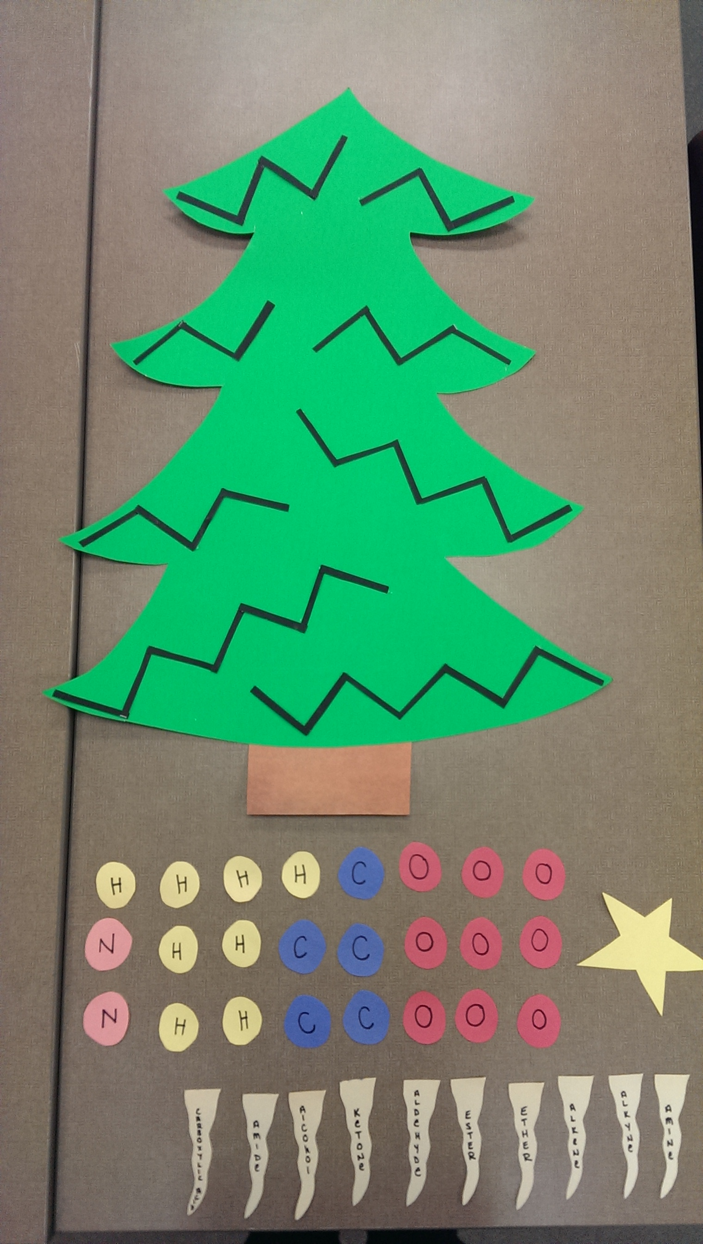
Star
Icicle
Ornament
Stencils

