Grade 12 University Organic Chemistry Lesson Plan
Title: Priority Naming and Review “ChemisTREE”
Course: Grade 12U Chemistry
Unit: B. Organic Chemistry
Time: 76 minutes
Overall Expectations:
B.2. Investigate organic compounds and organic chemical reactions, and use various methods to represent the compounds;
B3. Demonstrate an understanding of the structure, properties, and chemical behaviour of compounds within each class of organic compounds.
Specific Expectations:
B2.2. Use International Union of Pure and Applied Chemistry (IUPAC) nomenclature conventions to identify names, write chemical formulae, and create structural formulae for the different classes of organic compounds, including hydrocarbons, alcohols, aldehydes, ketones, carboxylic acids, esters, ethers, amines, amides, and simple aromatic compounds
B3.1 Compare the different classes of organic compounds, including hydrocarbons, alcohols, aldehydes, ketones, carboxylic acids, esters, ethers, amines, and amides, by describing the similarities and differences in names and structural formulae of the compounds within each class
B3.2. Describe the similarities and differences in physical properties (e.g., solubility in different solvents, odour, melting point, boiling point) within each class of organic compounds
Learning Objectives:
After this lesson, students will be able use the International Union of Pure and Applied Chemistry (IUPAC) nomenclature convention to write chemical formulae and name organic compounds that contain more than one functional group. The students will also be able to combine information learned in the unit so far to describe similarities and differences between organic compounds.

Success Criteria:
Students will understand how to name and identify different functional groups. They will be able to list different properties for each group and prioritize them within a structure. Students will have a visual aid in order to clarify and organize the information.
Major Concepts:
The major concept that will be covered in this lesson is the IUPAC naming and proper drawing of organic compounds with multiple functional groups.
A review activity of the structures, names, and properties of individual functional groups will be completed.
Materials and Equipment:
- Whiteboard markers/chalk
- Chemical Review (matching) Cards (24-30 cards)
- Priority Naming of Organic Compounds Handout Note and Practice Handout
- ChemisTREE stencils
- One green bristol board per group
- Scissors, glue, and markers
- Construction paper of various colours (to make ornaments and icicles)
- Yarn and beads (for “Christmas lights” used to form double bonds. These are optional, students may use construction paper)
Lesson Sequence:
- Mind's On - Review Activity of Esters, Amines and Amides (10 minutes)
This utilizes the practice of learning circles, where the students come together to share information and help one another to better understand a concept.
Prior to class beginning, the teacher should write 3-6 review questions on the board, regarding the naming of and structures of esters, amines, and amides. As students enter class, they are to begin quietly working on these questions. While the students are working, the teacher will pass out one matching card (containing either an IUPAC name or a chemical structure) to each student.Once all students have completed the review questions, they are to walk around the room and find the student with the matching card (each resulting pair should have one structure card and one name card). Students will work with this partner to take up the review questions, making corrections and asking for clarification if needed.
2. New Material - Priority Naming (15-20 minutes)
After the students have a concrete understanding of naming structures with one functional group, the instructor will introduce the concept of structures with multiple functional groups. The instructor will pass out the note “Priority Naming of Organic Compounds”. The instructor will go into further detail and explain to the students the steps for priority naming. The instructor will educate the students on how to find the principal functional group, determine the root name, and assign all remaining functional groups based on their position on the parent chain.
Next, the students will receive a handout with practice problems. The instructor will answer any questions the students have, using scaffolding techniques. As a wrap up for this part of the lesson, the instructor will put a few examples on the board and ask students to work through them together.
3. Self-Assessment (~10 minutes)
This is to be handed in so that the teacher is able to assess the amount of time that should be allocated in future lessons for review and practice.
After roughly 10 minutes of practice, the instructor will bring the students back together to take up the practice questions. Before breaking off into their groups for the review activity, the the students should individually complete an "exit card" on a separate piece of paper. They will have to name a new compound that has been drawn on the board, state one thing that they learned, and state one thing that they found difficult about topics covered in this lesson.
4. Review Project (Remainder of Class, ~35 minutes)
This project is due at the beginning of class two days after being assigned, which allows for students to work on it at home if not completed in the allocated time. For this reason, students may choose their group members.
The students are going to create an "Organic ChemisTREE" where they incorporate all aspects of organic chemistry learned thus far. This project will be completed in groups of 3-4. The branches of the tree will be decorated by hydrocarbons of chain lengths 3-8. Ornaments (labelled with various element symbols) will be added to the branches in order to create the structures of the functional groups learned in class. The students will then add icicles to the ends of the branches, which will have the name of the functional group that has been built. The top of the tree will be decorated by a star, which will show the structure of one of the aromatic compounds studied in this unit (ex. a benzene ring).
To accompany the visual aspect of this project, the students will complete a chart that will be attached to the back of their ChemisTREE, which will summarize structures, names, and properties of each of the groups.

Assessment:
The student’s will perform a self-assessment for the Mind’s On Review to evaluate their performance. The students will be allocated time to fix any misunderstandings from the day before. They will be allowed to work with their elbow partner to clarify any misconceptions. The exit cards will be used as formative assessment in determining if they understood the material. This will allow the instructor to identify any difficulties the students are having and clarify the misunderstandings. The Organic ChemisTREE will be marked based on a rubric.

Matching Cards

methyl pentanoate | ethyl butanoate | propyl pentanoate
propyl propanoate | butanamine | N-methyl-1-  propanamine
2-propanamine | N-ethyl-2-  butanamine | propanamide
N-methylethanamide | pentanamide | N-ethyl-1-  propanamide
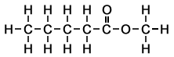 | 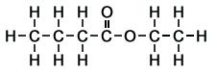 | 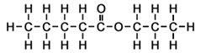
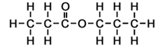 | 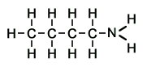
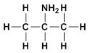 | 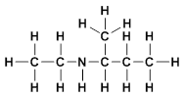 | 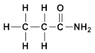
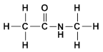 | 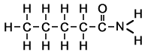 | 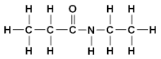

Priority Naming of Organic Compounds
Listed from HIGHEST to LOWEST priority, except those substituents in Group C have equivalent priority. Substituents are to be cited in alphabetical order.
Group A - Functional Groups Indicated by Prefix or Suffix
Family of Compound | Structure | Prefix | Suffix
Carboxylic Acid | 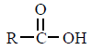 | carboxy - | -oic acid
Aldehyde | 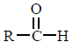 | oxo - (formyl) | -al
Ketone | 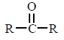 | oxo - | -one
Alcohol | 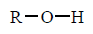 | hydroxy - | -ol
Amine | 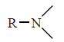 | amino - | -amine
Group B - Functional Groups Indicated by Suffix Only
Family of Compound | Structure | Prefix | Suffix
Alkene | 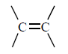 | N/A | -ene
Alkyne | 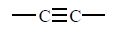 | N/A | -yne
Group C - Substituents Indicated by Prefix Only
Family of Compound | Structure | Prefix | Suffix
Alkyl |  | alkyl - (depends on R group) | N/A
Alkoxy | 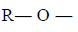 | alkoxy - | N/A
Halogen | 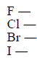 | fluoro -  chloro -  bromo -  iodo - | N/A
Miscellaneous substituents |  | nitro - | N/A
 |  | vinyl - | N/A
 | 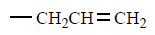 | allyl - | N/A
 | 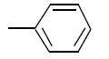 | phenyl - | N/A

Priority Naming Practice Name: ____________________
1) 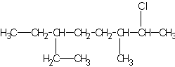 2) 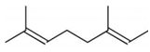

3) 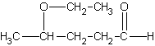 4) 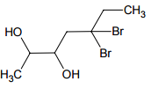

5) 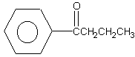 6)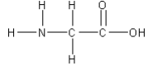

7)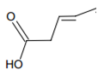

Priority Naming Practice - Answer Key
1) 2-chloro-6-ethyl-3-methyloctane
2) 2,6-dimethyl-2,6-octadiene
3) 4-ethoxypentanal
4) 5,5-dibromo-2,3-heptandiol
5) 1-phenyl-1-butanone
6) aminoethanoic acid
7) 3-pentenoic acid

