Lesson Plan

Teacher Candidates: Nicole Moussallem, Hani Shebani Tarhuni, Kristi Wiebe
Subject: Language
Grade/ Class: Kindergarten
Duration: 75 minutes
Lesson Topic: Word families –AT

Overall Expectations:
4. Communicate in writing, using strategies that are appropriate for beginners.

Specific Expectations:
4.4. Begin to use classroom resources to support their writing.

Learning/ Teaching Resources:
- Short Story
- Pedagogical tool
- Letters
- AT word family cards
- White board marker
- Who Lives in my House (Graphic Organizer)
Bridge-In (10 minutes):
- Gather the children on the carpet
- Show them the “Princess Story”
- Ask children what they think the story may be about
- Read the story
Introductory Activity/ Mini-lesson (15 minutes):
- Ask children to point out words that have the word –AT in them
- As the children identify words place the word on the pedagogical tool under “SAY IT”
- Ask the children to spell the word and then create the word under “BUILD IT”
- Ask the children how we spell the word and write the word under “WRITE IT”

Developmental Strategies / Participation (35 minutes):
- Provide each child with a handful of cards (-At family words)
- Provide each child with the pedagogical tool, letters and a dry-erase marker
- Children may explore “SAY IT, BUILD IT, WRITE IT”
- Pass out the graphic organizer Who Lives in my House as children create words encourage them to write their words in their graphic organizers
Concluding Activity (15 minutes):
- Gather the children on the carpet
- Ask children what words they have created with their pedagogical tool and what words live in their homes.
- Compare children’s words and discuss popular words
- Identify other words / encourage children to think of more complicated words
- Place words on word wall

Ongoing Assessment/ Evaluation:

FORMATIVE ASSESSMENT: children will be observed while creating their word families.
SUMMERATIVE ASSESSMENT: The teacher will ask the students to identify three words from the –AT family.

Follow-Up Activities/Ideas or Next Steps:
- Create a Word Family Wall with different “Homes” as children learn about new families the class creates a master home with 10 words from each family to refer to as the year progresses.
- Children are read different books focusing on different word families

The Word Family House

Directions: Look for words in the story that belong to this word family. Write your word in the house.

Name:_________________________________________________________________

Date:__________________________________________________________________

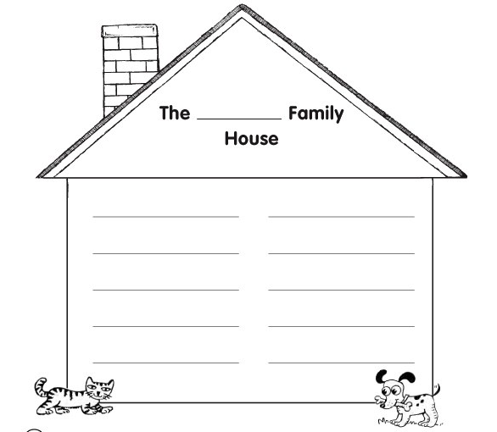

Once upon a time,...there was a Princess named Brat.

She lived in a big castle with her best friend Pat.

Brat and Pat they sat on a comfy mat.

Her Fat Nanny wanted to chat, chat, chat.

Suddenly, the cat smelled the scent of a smelly old rat.

Brat got scared and yelled, “Nanny get that big fat bat!”

That is next to the pink fluffy mat.

Nanny asked Brat to step outside, “don’t forget your hat, hat, hat!”

As Brat and Pat went outside they both heard a big SPLAT!

“Oh no, goodbye poor Rat”
And then the Fat Nanny, Brat and the Cat lived happily ever after with no fear of smelly old Rat.

-At Word Family
Cat  Sat  Fat  Bat  Rat  Hat | Mat  Pat  That  Brat  Flat  Chat  Splat
“Say it”

“Build It”

“Write It”
_ _ _ _ _ _ _ _ _ _ _ _ _ _ _ _ _ _ _ _ _

Cat 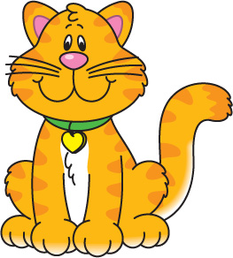
Hat 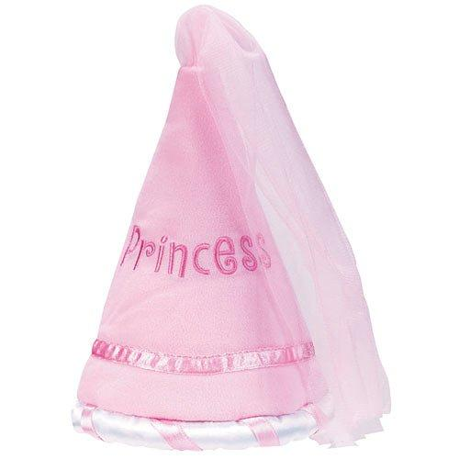
Bat 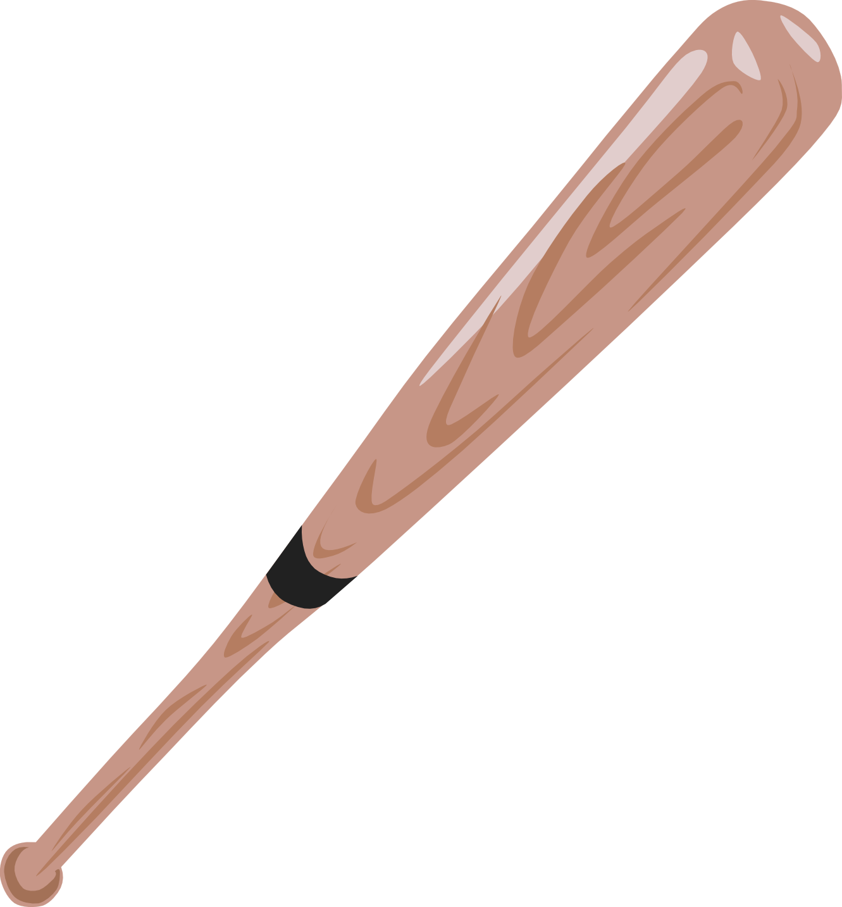

Mat

Splat 