The following are activity sheets required to play Chord Building Bingo.   
This is the “bingo” card that each student requires. Students mingle with other students to build the chord names provided on the sheet. They need to write in the note on the staff that each student had (that is in the chord) and they need to note the name of every student who built the chord.

Page 2 and 3 are the cut outs that each student will be given. Only give one note to each student. They will mingle around with their original note and when each student has made every chord that their note is present in they will trade in the note with the teacher for a new note. Every student will do this until they have completed their bingo sheet.

**NAME: ____________________**

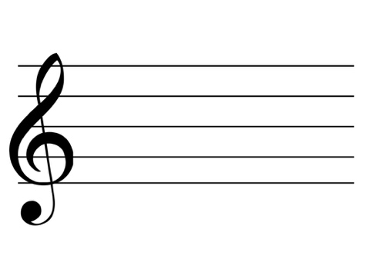

F Major

A Minor

C Major

Names Names Names

C7

D minor7

G7





Names Names Names



A Major

B7

E minor

Names Names Names

|  |  |  |  |
| --- | --- | --- | --- |
| http://kajp.org/allaboutmusictheory.com/wp-content/uploads/2014/10/C4TrebleNew.pngC  https://upload.wikimedia.org/wikipedia/commons/thumb/1/15/PianoKeyboard.svg/2000px-PianoKeyboard.svg.png | http://kajp.org/allaboutmusictheory.com/wp-content/uploads/2014/10/E4TrebleNew.pnghttps://upload.wikimedia.org/wikipedia/commons/thumb/1/15/PianoKeyboard.svg/2000px-PianoKeyboard.svg.pngE | https://classconnection.s3.amazonaws.com/751/flashcards/1680751/jpg/note-treble-g4-14354AF01CD69852A25.jpghttps://upload.wikimedia.org/wikipedia/commons/thumb/1/15/PianoKeyboard.svg/2000px-PianoKeyboard.svg.pngG | https://upload.wikimedia.org/wikipedia/commons/9/9e/A440.pnghttps://upload.wikimedia.org/wikipedia/commons/thumb/1/15/PianoKeyboard.svg/2000px-PianoKeyboard.svg.pngA |
| http://www.quiz.biz/uploads/quizz/833829/1_7SXEb.jpgC  https://upload.wikimedia.org/wikipedia/commons/thumb/1/15/PianoKeyboard.svg/2000px-PianoKeyboard.svg.png | https://upload.wikimedia.org/wikipedia/commons/thumb/1/15/PianoKeyboard.svg/2000px-PianoKeyboard.svg.pnghttp://www.mangore.com/upload/archivos_imagenes/the-6-open-strings.gifE | https://classconnection.s3.amazonaws.com/751/flashcards/1680751/jpg/note-treble-f4-143549BF94E30383573.jpghttps://upload.wikimedia.org/wikipedia/commons/thumb/1/15/PianoKeyboard.svg/2000px-PianoKeyboard.svg.pngF | https://upload.wikimedia.org/wikipedia/commons/9/9e/A440.pnghttps://upload.wikimedia.org/wikipedia/commons/thumb/1/15/PianoKeyboard.svg/2000px-PianoKeyboard.svg.pngA |
| http://www.quiz.biz/uploads/quizz/833829/1_7SXEb.jpgC  https://upload.wikimedia.org/wikipedia/commons/thumb/1/15/PianoKeyboard.svg/2000px-PianoKeyboard.svg.png | https://classconnection.s3.amazonaws.com/751/flashcards/1680751/jpg/note-treble-g4-14354AF01CD69852A25.jpghttps://upload.wikimedia.org/wikipedia/commons/thumb/1/15/PianoKeyboard.svg/2000px-PianoKeyboard.svg.pngG | https://classconnection.s3.amazonaws.com/751/flashcards/1680751/jpg/note-treble-b4-14354942F4F3AC433F0.jpghttps://upload.wikimedia.org/wikipedia/commons/thumb/1/15/PianoKeyboard.svg/2000px-PianoKeyboard.svg.pngB | https://s-media-cache-ak0.pinimg.com/736x/e9/2d/1e/e92d1e2ee94ca7a6391f670b803ea8b2.jpghttps://upload.wikimedia.org/wikipedia/commons/thumb/1/15/PianoKeyboard.svg/2000px-PianoKeyboard.svg.pngD |
| https://www.basicmusictheory.com/img/f-sharp-note-on-treble-clef.pngF-Sharp  https://www.basicmusictheory.com/img/f-sharp-note-on-treble-clef.png  https://upload.wikimedia.org/wikipedia/commons/thumb/1/15/PianoKeyboard.svg/2000px-PianoKeyboard.svg.png | https://classconnection.s3.amazonaws.com/856/flashcards/1052856/jpg/flash-cards-notes-1_03-13F591D3A8B6FC9DFF1.jpghttps://upload.wikimedia.org/wikipedia/commons/thumb/1/15/PianoKeyboard.svg/2000px-PianoKeyboard.svg.pngD | https://classconnection.s3.amazonaws.com/751/flashcards/1680751/jpg/note-treble-f4-143549BF94E30383573.jpghttps://upload.wikimedia.org/wikipedia/commons/thumb/1/15/PianoKeyboard.svg/2000px-PianoKeyboard.svg.pngF | https://upload.wikimedia.org/wikipedia/commons/9/9e/A440.pnghttps://upload.wikimedia.org/wikipedia/commons/thumb/1/15/PianoKeyboard.svg/2000px-PianoKeyboard.svg.pngA |
| http://www.quiz.biz/uploads/quizz/833829/1_7SXEb.jpgC  https://upload.wikimedia.org/wikipedia/commons/thumb/1/15/PianoKeyboard.svg/2000px-PianoKeyboard.svg.png | https://upload.wikimedia.org/wikipedia/commons/9/9e/A440.pngA  https://upload.wikimedia.org/wikipedia/commons/thumb/1/15/PianoKeyboard.svg/2000px-PianoKeyboard.svg.png | http://kajp.org/allaboutmusictheory.com/wp-content/uploads/2014/10/E4TrebleNew.pnghttps://upload.wikimedia.org/wikipedia/commons/thumb/1/15/PianoKeyboard.svg/2000px-PianoKeyboard.svg.pngE | https://classconnection.s3.amazonaws.com/751/flashcards/1680751/jpg/note-treble-g4-14354AF01CD69852A25.jpghttps://upload.wikimedia.org/wikipedia/commons/thumb/1/15/PianoKeyboard.svg/2000px-PianoKeyboard.svg.pngG |
| https://classconnection.s3.amazonaws.com/751/flashcards/1680751/jpg/note-treble-b4-14354942F4F3AC433F0.jpgB  https://upload.wikimedia.org/wikipedia/commons/thumb/1/15/PianoKeyboard.svg/2000px-PianoKeyboard.svg.png | http://www.mangore.com/upload/archivos_imagenes/the-6-open-strings.gifE  https://upload.wikimedia.org/wikipedia/commons/thumb/1/15/PianoKeyboard.svg/2000px-PianoKeyboard.svg.png | https://classconnection.s3.amazonaws.com/751/flashcards/1680751/jpg/note-treble-g4-14354AF01CD69852A25.jpghttps://upload.wikimedia.org/wikipedia/commons/thumb/1/15/PianoKeyboard.svg/2000px-PianoKeyboard.svg.pngG | https://classconnection.s3.amazonaws.com/751/flashcards/1680751/jpg/note-treble-b4-14354942F4F3AC433F0.jpghttps://upload.wikimedia.org/wikipedia/commons/thumb/1/15/PianoKeyboard.svg/2000px-PianoKeyboard.svg.pngB |
| B  https://upload.wikimedia.org/wikipedia/commons/thumb/1/15/PianoKeyboard.svg/2000px-PianoKeyboard.svg.png | https://www.earmaster.com/images/book/m11641/m11641.id223692.pnghttps://upload.wikimedia.org/wikipedia/commons/thumb/1/15/PianoKeyboard.svg/2000px-PianoKeyboard.svg.pngD-Sharp | F-Sharp  https://www.basicmusictheory.com/img/f-sharp-note-on-treble-clef.png  https://upload.wikimedia.org/wikipedia/commons/thumb/1/15/PianoKeyboard.svg/2000px-PianoKeyboard.svg.png | http://www.music-paper.com/ImagesAccidentals/C-sharp.jpghttps://upload.wikimedia.org/wikipedia/commons/thumb/1/15/PianoKeyboard.svg/2000px-PianoKeyboard.svg.pngA |

**ANSWER KEY**

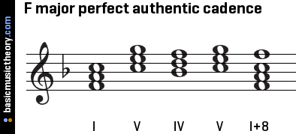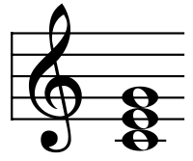

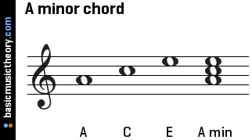

F Major

A Minor

C Major

Names Names Names

CMaj7

D minor7

G7

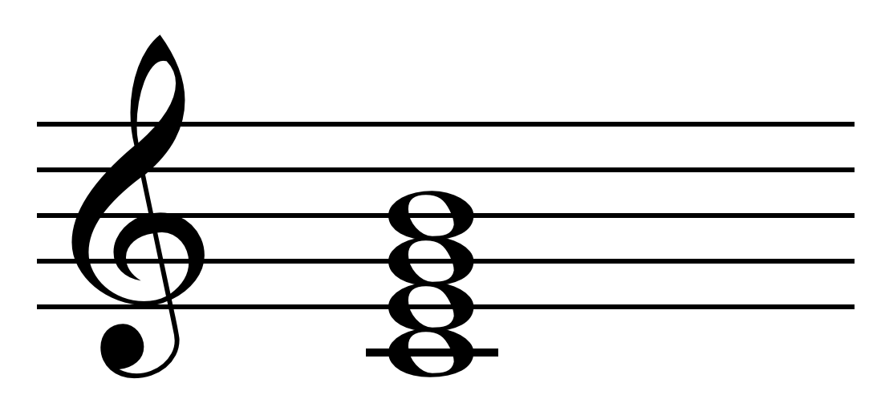

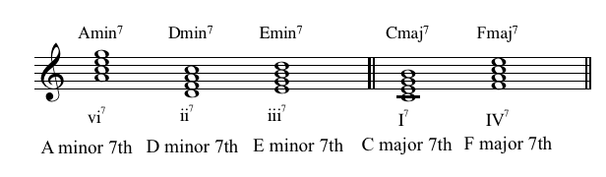

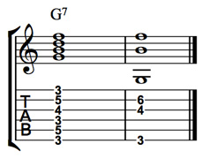

Names Names Names

A Major

B7

E minor

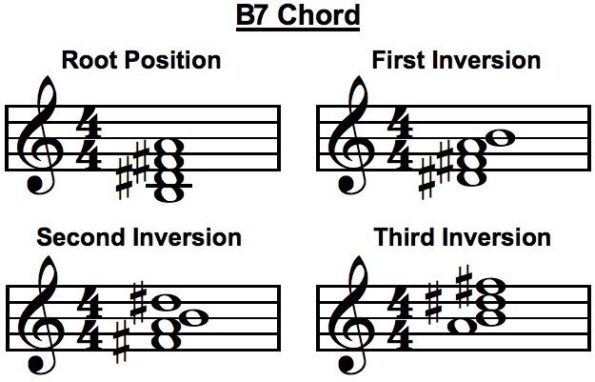

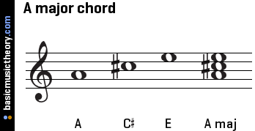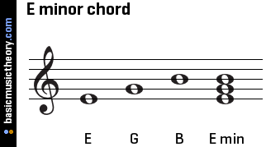

Names Names Names