A vocabulary English class through the game “Story Collector’s Odyssey”
Michelle Contractor, Xintian Ren and Zhenli Liu

Topic | Borad game “Story Collector’s Odyssey”
Key words | Interactive storytelling; Board game; Multicultural perspectives
Course | English
Class/ Grade | Grade 6
Duration | 90 minutes
Overall Expectations | B1. apply listening, speaking, and non-verbal communication skills and strategies to understand and communicate meaning in formal and informal contexts and for various purposes and audiences  A1. demonstrate an understanding of how the seven transferable skills (critical thinking and problem solving; innovation, creativity, and entrepreneurship; self-directed learning; collaboration; communication; global citizenship and sustainability; and digital literacy) are used in various language and literacy contexts
Specific Expectations | B1.2 select and use a variety of listening strategies before, during, and after listening to comprehend information communicated orally and non-verbally, seek clarification, and develop a relevant response appropriate to the context  A3.2 demonstrate an understanding of the historical contexts, contributions, lived experiences, and perspectives of a diversity of individuals and communities, including those in Canada, by exploring the concepts of identity, self, and sense of belonging in a variety of culturally responsive and relevant texts  Every student feels a greater sense of belonging to their class and develops a greater interest and deeper understanding of their classmates’ diverse cultures
Materials Needed | - Board game setup titled "Story Collector's Odyssey"  - A world map or globe  - Character cards representing 9 countries (the home countries of the characters in the game are the actual cultural backgrounds of the students from the class), in our case, Canada, India, China, Vietnam, Sri Lanka, Bangladesh, Germany, Iran, and Palestine  - illustrations for words to be learned: vanquish, greedy, defend, Vernal Equinox, dusk, to bid farewell, grieve, oviparous, and locomotive  - Story cards with authentic stories from the represented countries  - Question cards with 3 types of questions: guessing the origin country; vocabulary questions and critical questions  - Writing materials or whiteboard for vocabulary reinforcement
Class Structure | - Introduction (5 minutes)  - Welcome students and introduce the concept of "Story Collector's Odyssey" by referencing to the famous Brothers Grimm.  - Briefly explain the objectives of the game and how it will help them learn new vocabulary and understand different cultures. Teacher can tell the students that the cultures involved in the game consists of the cultures of the classmates.  - Game Setup (5 minutes)  - Set the world map.  - Divide the students into several groups of players (the number of groups is flexible depending on the number of students in the classroom) and ensure the diversity within each group. Each group represents a publisher, and students are allowed to discuss and come up with a name for their publisher.  - Explain the rule. The groups will earn points by interactively listening to the stories and answering questions asked by each character. The group who earns the highest point from the character will collect their story. Finally, the publisher collecting the most stories win.  - Play the Game (65minutes) – How to Play  Each round of the game consists of the following moves, with each round taking approximately 7 minutes:  1. Guessing the origin of the character  The board game host (the teacher) picks randomly a card from the character card pile and a character card from the stack.  After being shown the picture, players “buzz in” to guess the character’s national origin by the general outfit and physical appearance. Students then place the character cards in their corresponding locations on the map.  Scoring: Students who correctly guess the origin without any clues and earn 5 points. Those who get the answer with the help of clues earn 3 points. If a student recognizes the character and voluntarily give the clue also earn 3 points.  2. Understanding and Defining the identified vocabulary  The teacher takes the tone of the character to narrate the story. In each story is incorporated a new word to be learned. When the teacher reads the new word, they writes it down in the organizer and explaining it by showing the picture, making a physical gesture or providing detailed verbal explanations.  After the story, players “buzz in” to answer the question related to the word’s meaning. Meanwhile, the teacher writes down the right answer in the organizer.  Scoring: Player who gets the right answer earns 5 points.  3. Critical and open-ended question to inspire cultural reflections  The final question would be a critical question based on the story which provokes deeper thoughts.  Scoring: According to depth of response, creativity, empathy, and engagement, the answer will be scored from 5-10.  The group with the highest cumulative score will successfully collect the story.  After 9 rounds of game, pick out the publisher group who collects most stories as the winner.  - Wrap-up, Reflection and Discussion (15 minutes)  1. Review the words that have been learned with the help of the writing materials to expand the language skill.  2. Students engage in discussion about the stories, sharing their thoughts and perspectives. In this process, the teacher encourages students to relate the story to their own experiences and delve into discussion. The emphasis is on the importance of cultural understanding and empathy.  Questions that can be asked could be:  1) Which story impressed you most and why?  2) Which character do you like the best and why?  3) What commonalities can you find between some of the stories?  4) What is special about each culture’s story?  5) What question do you have about a certain story? (Students who have the “expertise” could give the answer.)
Homework Assignment | Students select a story to undertake the continuation.
Rflection and Conclusion | Pros:  1. By incorporating characters from diverse countries, Story Collector’s Odyssey promotes cultural understanding and appreciation among students, fostering a sense of inclusivity and global awareness.  2. Interactive storytelling hooks students’ attention by immersing them in the narrative and this contextualized learning  3. The choice of game characters is flexibly decided by the classroom demographics. Every student could find themselves an expert somewhere in the class, which could effectively prevent marginalization.  Issues that need to be addressed:  1. Care must be taken in regard of cultural sensitivity.  2. The rubric and scoring system for open-ended questions needs further thoughts.  3. The characters and stories in the game need to be adapted for different classes.

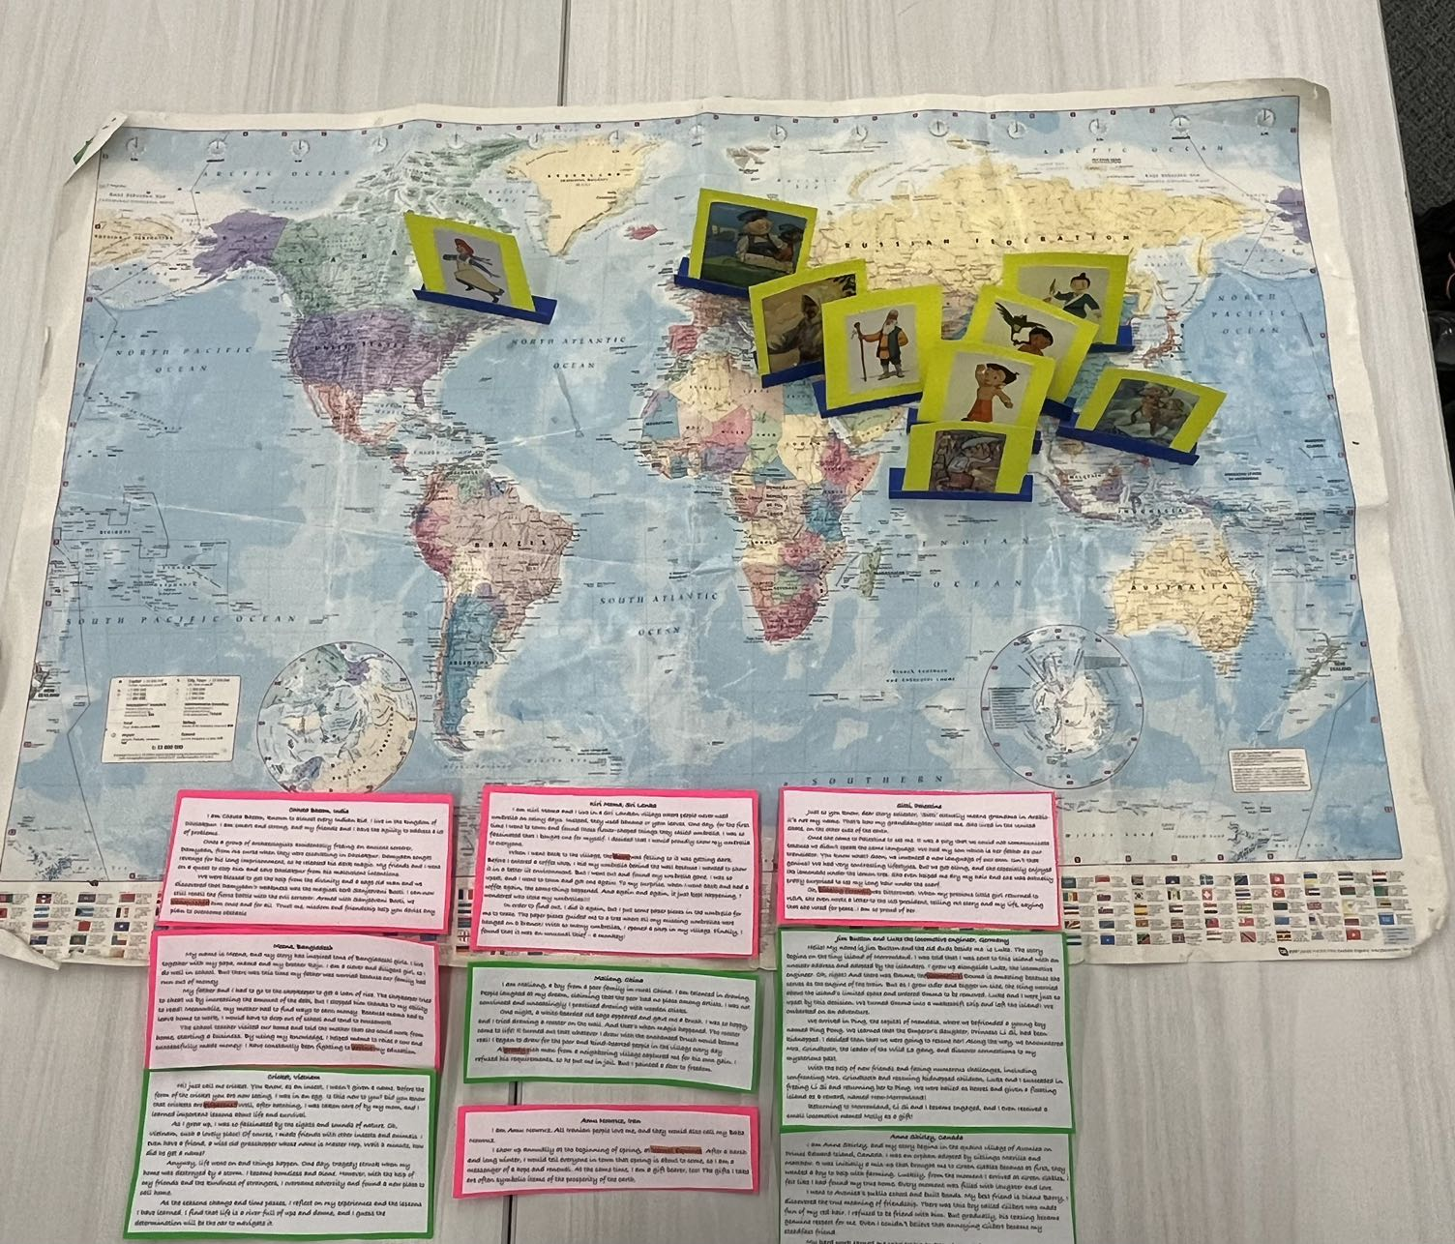
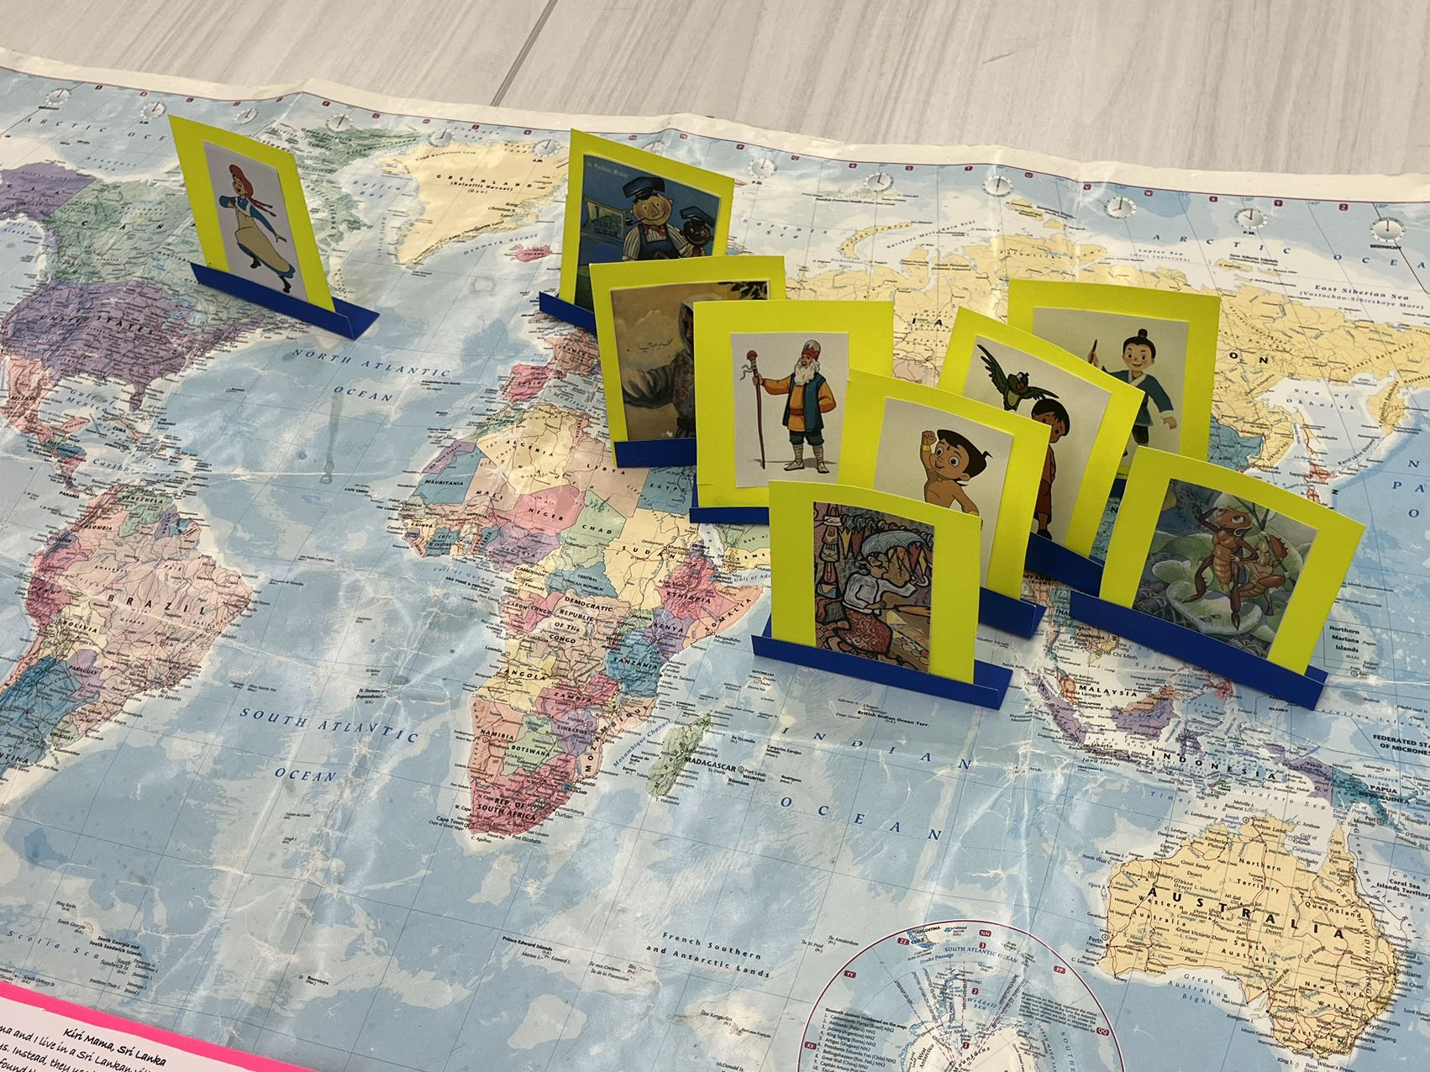

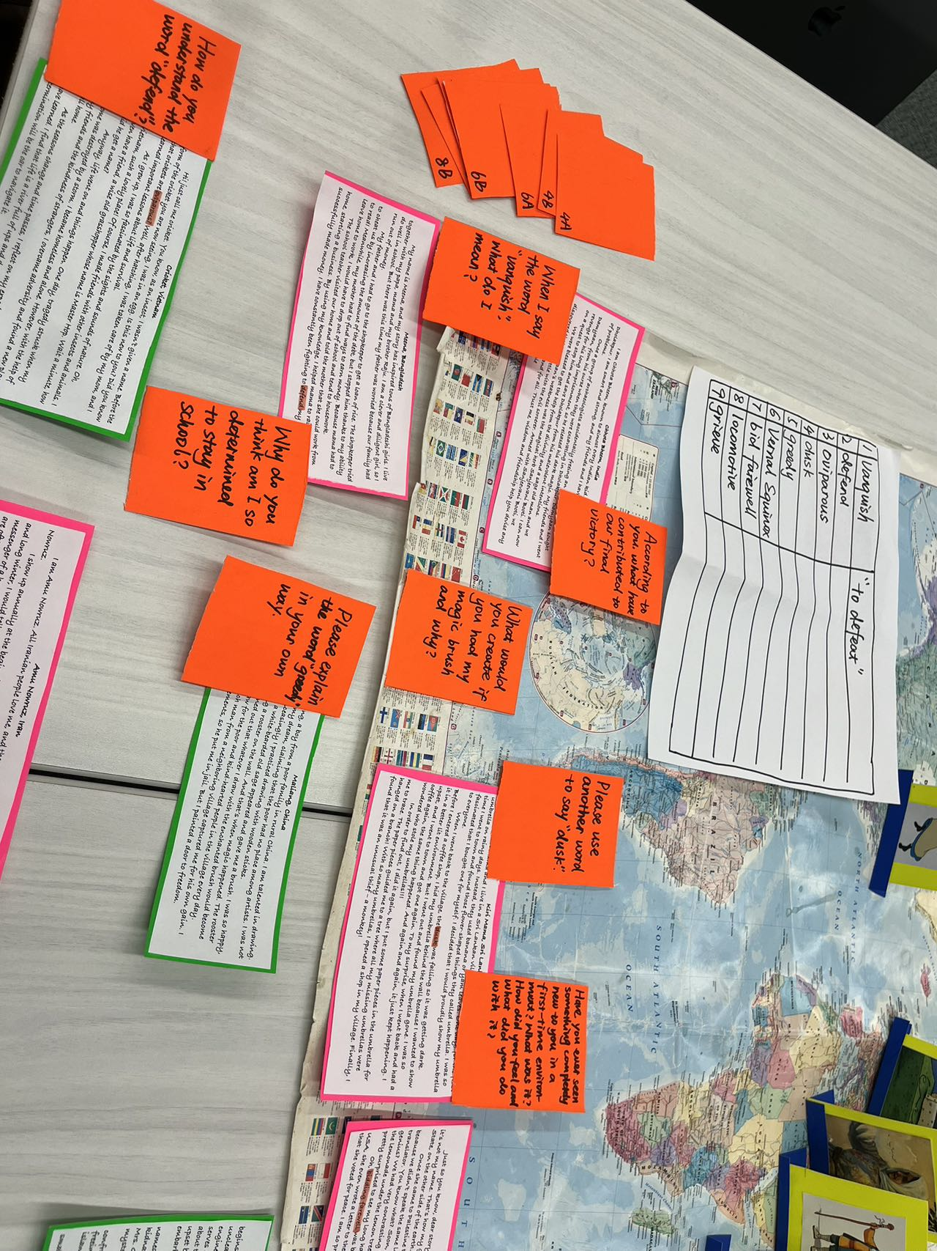
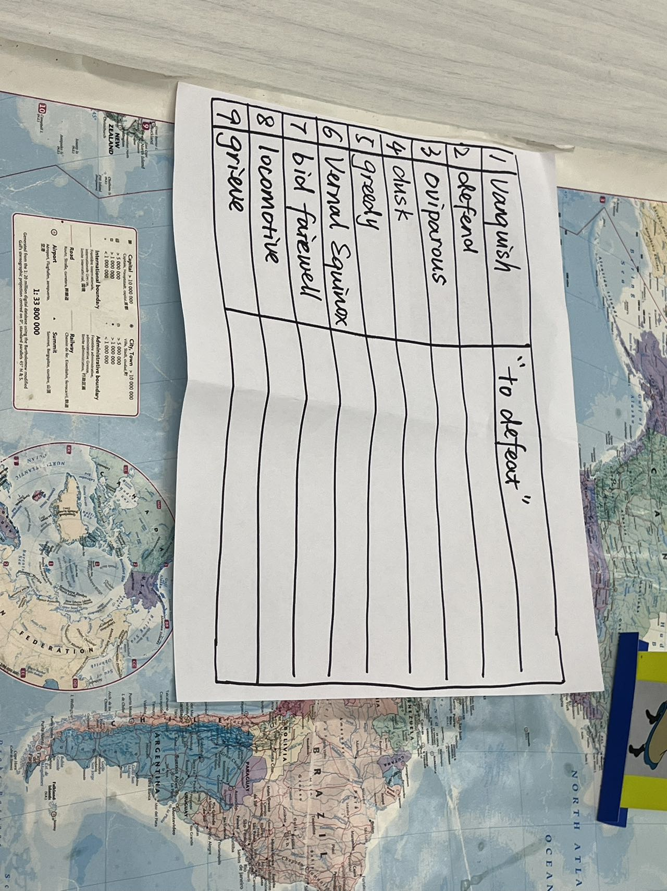

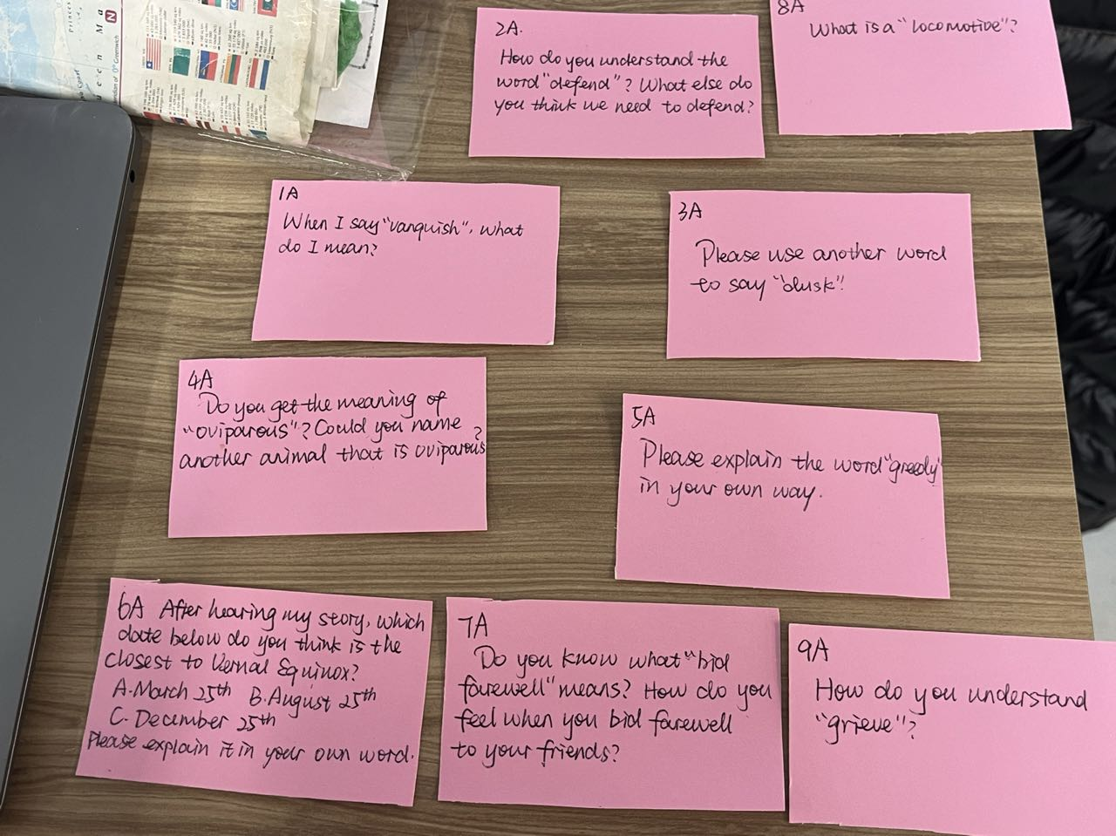
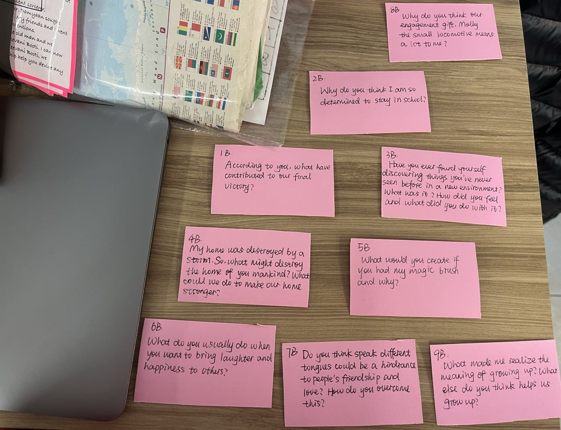
Appendix

No.1 Chhota Bheem, India
I am Chhota Bheem, known to almost every Indian kid. I live in the kingdom of Dholakpur. I am smart and strong, and my friends and I have the agility to address a lot of problems.
Once a group of archaeologists accidentally freeing an ancient sorcerer, Damyaan, from his curse when they were excavating in Dholakpur. Damyaan sought revenge for his long imprisonment, so he released his dark magic. My friends and I went on a quest to stop him and save Dholakpur from his malevolent intentions.
We were blessed to get the help from the divinity and a sage old man. We discovered that Damyaan’s weakness was the magical herb Sanjeevani Booti. I can now still recall the fierce battle with the evil sorcerer. Armed with Sanjeevani Booti, we vanquished him once and for all. Trust me, wisdom and friendship help you devise any plan to overcome an obstacle.

Game question card:
1A. When I say “vanquish”, what do I mean?
1B. According to you, what have contributed to our final victory?

No.2 Meena, Bangladesh
My name is Meena, and my story has inspired tons of Bangladeshi girls. I live together with my papa, mama and my brother Raju. I am a clever and diligent girl, so I do well in school. But there was this time my father was worried because our family had run out of money.
My father and I had to go to the shopkeeper to get a loan of rice. The shopkeeper tried to cheat us by increasing the amount of the debt, but I stopped him thanks to my ability to read! Meanwhile, my mother had to find ways to earn money. Because mama had to leave home to work, I would have to drop out of school and tend to housework.
The school teacher visited our home and told the mother that she could work from home, starting a business. By using my knowledge, I helped mama to raise a cow and successfully made money. I have constantly been fighting to defend my education.

Game question card:
2A. How do you understand the word “defend”? What else do you think we need to defend?
2B. Why do you think am I so determined to stay in school?

No.3 Kiri Mama, Sri Lanka
I am Kiri Mama and I live in a Sri Lankan village where people never used umbrella on rainy days. Instead, they used banana or yam leaves. One day, for the first time I went to town and found those flower-shaped things they called umbrella. I was so fascinated that I bought one for myself. I decided that I would proudly show my umbrella to everyone.
When I went back to the village, the dusk was falling so it was getting dark. Before I entered a coffee shop, I hid my umbrella behind the wall because I wanted to show it in a better lit environment. But I went out and found my umbrella gone. I was so upset, and I went to town and got one again. To my surprise, when I went back and had a coffee again, the same thing happened. And again and again, it just kept happening. I wondered who stole my umbrellas!!!
In order to find out, I did it again, but this time I put some paper pieces in the umbrella for me to trace. The paper pieces guided me to a tree where all my missing umbrellas were hanged on a branch! With so many umbrellas, I opened a shop in my village. Finally, I found that it was an unusual thief – a monkey!

Game question card
3A. Please use another word to say “dusk”.
3B. Have you ever found yourself discovering things you've never seen before in a new environment? What was it? How did you feel and what did you do with it?

No.4 Cricket, Vietnam
Hi! Just call me cricket. You know, as an insect, I wasn’t given a name. Before the form of the cricket you are now seeing, I was in an egg. Is this new to you? Did you know that crickets are oviparous? Well, after hatching, I was taken care of by my mom, and I learned important lessons about life and survival.
As I grew up, I was so fascinated by the sights and sounds of nature. Oh, Vietnam, such a lovely place! Of course, I made friends with other insects and animals. I even have a friend, a wise old grasshopper whose name is Master Hop. Wait a minute, how did he get a name?
Anyway, life went on and things happen. One day, tragedy struck when my home was destroyed by a storm. I became homeless and alone. However, with the help of my friends and the kindness of strangers, I overcame adversity and found a new place to call home.
As the seasons change and time passes, I reflect on my experiences and the lessons I have learned. I find that life is a river full of ups and downs, and I guess the determination will be the oar to navigate it.

Game question card:
4A. Do you get the meaning of “oviparous”? Could you name another animal that is oviparous?
4B. My home was destroyed by a storm. So, what might destroy the home of you mankind? What could we do to make our home stronger?

No.5 Maliang, China
I am Maliang, a boy from a poor family in rural China. I am talented in drawing. People laughed at my dream, claiming that the poor had no place among artists. I was not convinced and unceasingly I practiced drawing with wooden sticks.
One night, a white-bearded old sage appeared and gave me a brush. I was so happy, and I tried drawing a rooster on the wall. And that’s when magic happened. The rooster came to life! It turned out that whatever I draw with the enchanted brush would become real! I began to draw for the poor and kind-hearted people in the village every day.
A greedy rich man from a neighboring village captured me for his own gain. I refused his requirements, so he put me in jail. But I painted a door to freedom.

Game question card:
5A. Please explain the word “greedy” in your own way.
5B. What would you create if you had my magic brush and why?

No. 6 Amu Nowruz, Iran
I am Amu Nowruz. All Iranian people love me, and they would also call my Baba Nowruz.
I show up annually at the beginning of spring, at Vernal Equinox. After a harsh and long winter, I would tell everyone in town that spring is about to come, so I am a messenger of a hope and renewal. At the same time, I am a gift bearer, too! The gifts I take are often symbolic items of the prosperity of the earth.

Game question card:
6A. After hearing my story, which date do you think is the closest to Vernal Equinox?
A. March 25th B. August 25th C. December 25th
Could you please explain Vernal Equinox in your own word?
6B. What do you usually do when you want to bring laughter and happiness to people?

No.7 Sitti, Palestine
Just so you know, dear story collector, ‘Sitti’ actually means grandma in Arabic- it’s not my name. That’s how my granddaughter called me. She lived in the United State, on the other side of the earth.
Once she came to Palestine to see me. It was a pity that we could not communicate because we didn’t speak the same language. We had my son which is her father as our translator. You know what? Soon, we invented a new language of our own. Isn’t that genius? We had very contrasting lifestyles, but we got along, and she especially enjoyed the lemonade under the lemon tree. She even helped me dry my hair and she was actually pretty surprised to see my long hair under the scarf.
Oh, bidding farewell was bittersweet. When my precious little girl returned to USA, she even wrote a letter to the US president, telling mt story and my life, saying that she voted for peace. I am so proud of her.

Game question card:
7A. Do you know what “bid farewell” means? How do you feel when you bid farewell
7B. Do you think speaking different tongues could be a hindrance to people's friendship and love? How do you overcome this?

No.8 Jim Button and Luke the locomotive engineer, Germany
Hello! My name is Jim Button and the old dude beside me is Luke. The story begins on the tiny island of Morrowland. I was told that I was sent to this island with an unclear address and adopted by the islanders. I grew up alongside Luke, the locomotive engineer. Oh, right! And there was Emma, the locomotive. Emma was amazing because she served as the engine and the leader of the train. But as I grew older and bigger in size, the King worried about the island's limited space and ordered Emma to be removed. Luke and I were just so upset by this decision. We turned Emma into a makeshift ship and left the island! We embarked on an adventure.
We arrived in Ping, the capital of Mandala, where we befriended a young boy named Ping Pong. We learned that the emperor’s daughter, Princess Li Si, had been kidnapped. I decided then that we were going to rescue her! Along the way, we encountered Mrs. Grindtooth, the leader of the Wild 13 gang, and discovered connections to my mysterious past.
With the help of new friends and facing numerous challenges, including confronting Mrs. Grindtooth and rescuing kidnapped children, Luke and I succeeded in freeing Li Si and returning her to Ping. We were hailed as heroes and given a floating island as a reward, named New-Morrowland!
Returning to Morrowland, Li Si and I became engaged, and I even received a small locomotive named Molly as a gift!

Game question card:
8A. What is a “locomotive”?
8B. Why do you think our engagement gift, Molly the small locomotive means a lot to me?

No.9 Anne Shirley, Canada
I am Anne Shirley, and my story begins in the quaint village of Avonlea on Prince Edward Island, Canada. I was an orphan adopted by siblings Marilla and Matthew. It was initially a mix-up that brought me to Green Gables because at first, they wanted a boy to help with farming. Luckily, from the moment I arrived at Green Gables, I felt like I had found my true home. Every moment was filled with laughter and love.
I went to Avonlea’s public school and built bonds. My best friend is Diana Barry, I discovered the true meaning of friendship. There was this boy called Gilbert who made fun of my red hair. I refused to be friend with him. But gradually, his teasing became genuine respect for me. Even I couldn’t believe that annoying Gilbert became my steadfast friend.
My hard work earned me scholarship to attend school. But Matthew tragically died of heart attack after reading the news that Abbey Bank where we kept all our money had failed. I grieved the loss of someone I loved. I realized then that it was time for me to embrace adulthood and responsibilities.

Game question card:
9A. How do you understand “grieve”?
9B. What made me realize the meaning of growing up? What else do you think helps us grow up?

