Melody LaBonté
Multiliteracies Project
January 16th, 2019
Literary Devices Escape Room

Description

This in-class activity is based on the popular escape room games. Escape rooms are physical adventure games typically set in closed rooms wherein participants solve series of puzzles to reveal the clues needed to escape the rooms. For this activity, the escape room experience would be replicated by dividing the class into small groups and having them race to complete all of the puzzles, and thus find all of the clues, before the other groups. This specific escape room is meant to review literary devices.

The Pedagogical Tool

Teacher Instructions: Each of the six tasks, including instructions and materials, should be separated into a different envelope. A copy of each task should be made for each group. For example, if the class is divided into four groups, then enough task envelopes would need to be made for each of those groups to have all six envelopes (four copies of Task #1, four copies of Task #2, etc.). At the beginning of the activity, each group will start with Task #1. When they complete the task, they will be given a letter clue and the next task envelope. The teacher is responsible for checking each group’s work and giving them the next task and clue once it is completed accurately. The first group to complete all six tasks, and thus find all six letter clues spelling out the word “poetry,” will win the game. The letters may be handed out in a random order and should spell out an answer to the quest. In this case, the class would be prompted to use the letter clues to decipher the topic of our new unit.
Student Instructions: Students are detectives that must decipher the topic of our new unit! Complete each task accurately and receive a letter clue that will help you piece together the topic!

Letter Clues:

P | O | E | T | R | Y
P | O | E | T | R | Y
P | O | E | T | R | Y
P | O | E | T | R | Y

*Disclaimer: in this case, the clues are letters used to spell out the word “poetry” because this activity is being used as an introduction to the poetry unit; however, individual teachers can choose to create differentiate clues. Sone alternate ideas include using numbers to unlock a treasure box or clues to the location of the prize.

Tasks: Link to PDF

Task 1: Personification
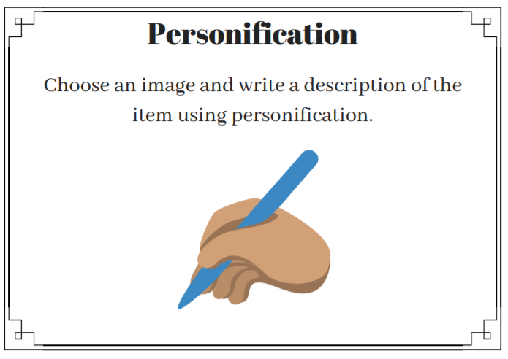

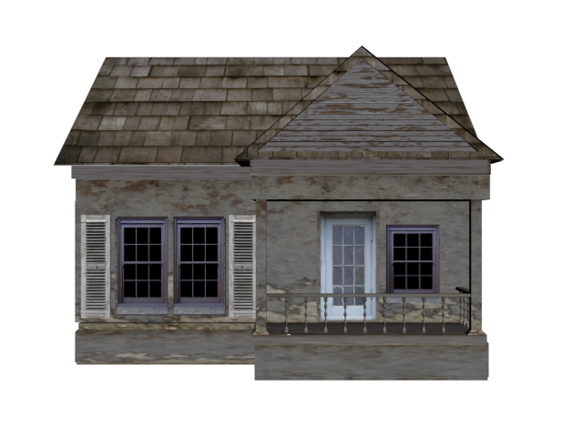

Task 2: Imagery

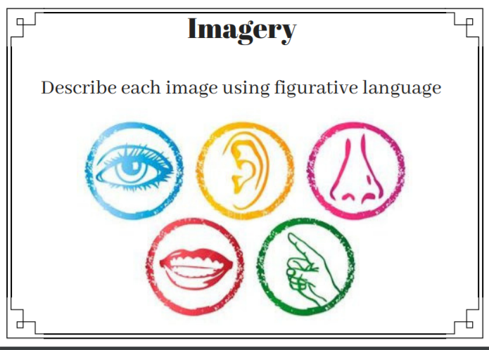

Task 3: Metaphors and Similes
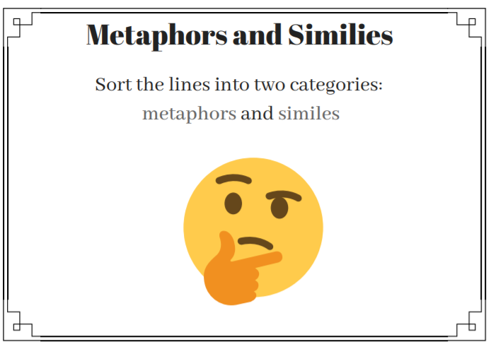

Sly as a fox | As fast as a cheetah | Poor as dirt | You are the wind beneath my wings | You are my sunshine
He eats like a pig | As cool as a cucumber | Slow as a snail | You are my rock | Her heart is gold
She slept like a dog | Dry as a desert | The garden was a jungle of weeds | He was a tornado, blasting through the hall | The stormy ocean was a raging bull
Brave as a lion | Cold as ice | Don’t be a couch potato | You are my knight in shining armour | Love is a battlefield

Task 4: Onomatopoeia

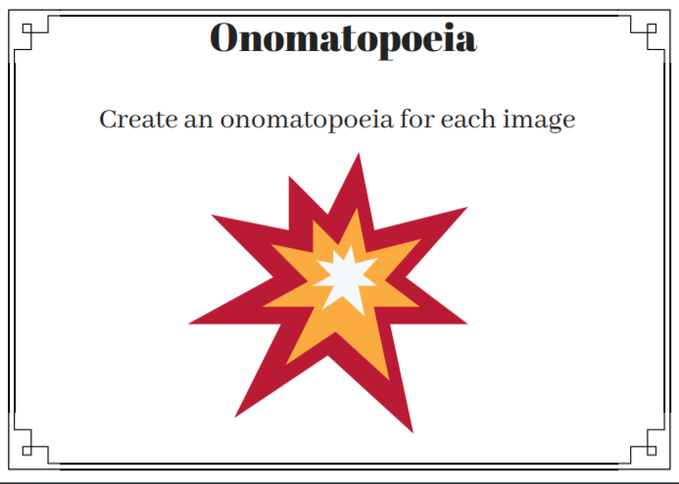

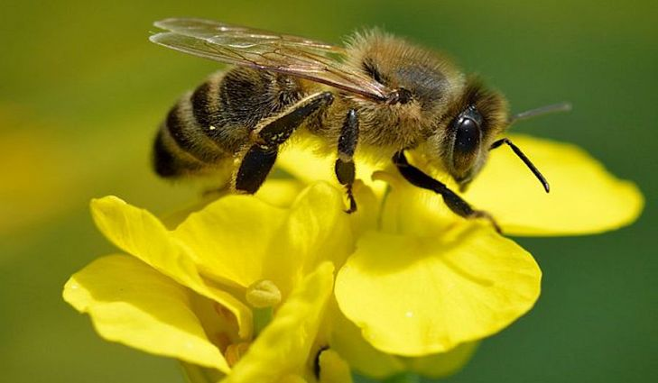

Task 5: Alliteration

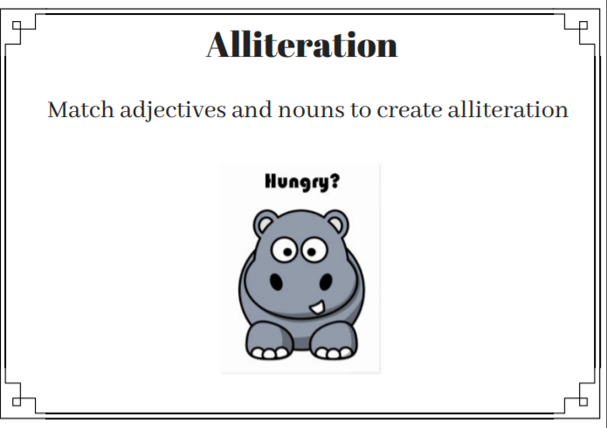

Happy | Healthy | Super | Beautiful | Cozy
Mad | Darling | Innovative | Wonderful | Lovely
Daring | Adventurous | Lazy | Crazy | Joyous
Junebug | Chris | Lizards | Aardvark | Donkey
Llama | Windsor | Irene | Duck | Max
Cat | Ballerina | Sandwich | Horse | Hippo

Task 6: Rhyme

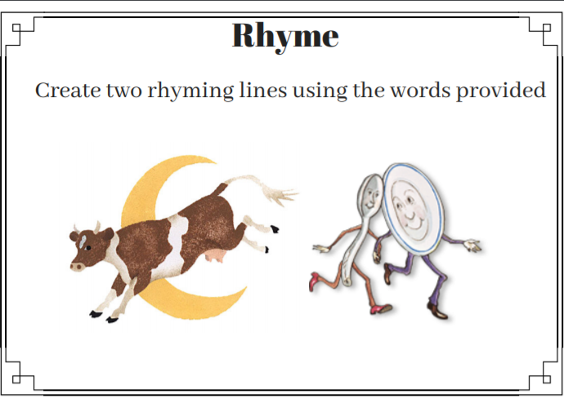

like | as | the | because | the
are | dated | please | apple | before
married | sat | when | fight | carried
bunny | Beyonce | dark | as | is
park | cheese | was | fiancé | light
cat | bite | air | brat | breeze
like | after | bear | buried | are
was | the | chappel | stated | sunny

Other Resources Needed:
- Large envelopes to separate each task
- A prize for the winning team

